GeoSurveillance 1.1
User’s Manual

June 6, 2007

Gyoungju Lee, Ikuho Yamada, and Peter A. Rogerson
NCGIA (National Center for Geographic Information and Analysis)
Department of Geography
State University of New York at Buffalo

Copyright© December 2006
Table of Contents page
Changes from version 1.0 to 1.1 4
1. Introduction 4
What kinds of questions can GeoSurveillance answer?
2. Structure of GeoSurveillance 7
3. GIS Functions in GeoSurveillance 8
4. Data Format and Sample Dataset 10
5. Spatial Weight Scheme 13
5.1 Constructing the spatial weight matrix
5.2 Bandwidth
6. Cluster Detection – Retrospective Tests 15
6.1 The Score Statistic
6.2 The M Statistic
6.3 Legend and Mapping
6.4 Illustration of the Score and the M Statistic
7. Cluster Detection – Prospective Tests 35
7.1 Definition of the Cumulative Sum Statistic
7.2 Period setting
7.3 Cusum options
7.4 Parameter setting
7.5 Animation speed
7.6 Illustration
8. Other Tools 48
8.1 View attribute of ESRI shapefile
8.2 Cusum tool
8.3 Export
8.4 Get p-value
8.5 Get centroid
9. Help 53
9.1 Manual
9.2 About GeoSurveillance

Changes from version 1.0 to 1.1
Several relatively minor changes have been made from the previous version. The range of methods covered with GeoSurveillance, as well as the method of data input, have remained the same.
The alignment of column heading has been improved. Graphs of statistics for a range of sigma values have been improved (through improved labeling, and through the addition of critical values on the graph). p-value calculations for global statistics are included. It is now possible to specify a sigma value of zero as the lower range when specifying a range of sigma values.
Finally, please note that this manual has not yet been fully updated; screen shots in the manual are taken from version 1.1.

1. Introduction
GeoSurveillance is software that combines spatial statistical routines with some basic Geographic Information Systems (GIS) functions to carry out retrospective and prospective statistical tests for the detection of geographic clustering. In this software, the focus is primarily on the spatial statistical analysis. Consequently, full GIS functionality is not provided. GIS functions are limited to map-display related operations, such as loading maps, coloring based on legend schemes predefined internally, zooming in, zooming out, panning, etc. If necessary, the analysis results can be saved so that they can be conveniently used in other commercial GIS if more sophisticated GIS operations are required. This software provides interfaces so that the user can save the analysis results in a text file format when necessary. Since the software was written in Visual Basic 6.0 without using any third party controls, it is small and stand-alone. This manual will provide detailed explanation of the operation of GeoSurveillance.

What kinds of questions can GeoSurveillance answer?
(a) Retrospective testing of the null hypothesis of no spatial clustering: Traditional statistical tests of the null hypothesis of no geographic clustering are retrospective; they are carried out at a particular point in time, using previously collected spatial data on statistical tests for cluster detection. Traditional examples of such statistics are the nearest neighbor statistic, the quadrat test, K-functions, and Moran’s I.
Spatial cluster detection may be (a) local (focused), or (b) global (general), or (c) may involve a search for the maximum of local statistics. In the first case, a test for increased risk around a prespecified focus is carried out. In the second, a single statistic is used to summarize any deviations from expectations; a rejection of the null hypothesis of spatial randomness gives limited results, since the size and location of clusters is not revealed. The final class of tests can be used to find both cluster size and location when these are unknown a priori (Besag and Newell 1991).
GeoSuveillance provides retrospective tests for each of these classes of cluster detection. Rather than provide a broad suite of many methods, the software is built around the objective of providing an integrated set of tests. At its core is the local score statistic, which is a well-known and powerful approach for testing whether incidence is raised around a predefined spatial location (see, e.g. Lawson 2000; Waller and Gotway 2004). The score statistic for a given location is essentially a weighted sum of the deviations between observed and expected values in the vicinity of the predefined location of interest. A global score statistic is also derived (based upon the local statistics), to provide a single statistic associated with the null hypothesis of no spatial pattern. Finally, users will perhaps most often be interested in assessing the statistical significance of all of local score statistics; this will be the case when the location of the cluster is not known beforehand. This requires accounting for the fact that many hypotheses are being tested (one for each region, at a particular geographic scale), and furthermore, these tests are correlated. GeoSurveillance provides for this assessment of its statistical significance.
GeoSurveillance is designed primarily for data that are available for a set of subregions. For each subregion, observed and expected numbers of cases are assumed to be available.

(b) Prospective monitoring of local statistics as new data become available periodically, to detect new clusters as quickly as possible
When new data become available on a regular basis, the periodic tests described in (a) may be carried out repeatedly, but again, the testing of multiple hypotheses will, without additional considerations, lead to false detection of clustering more often than is desirable. To account for these issues of multiple hypothesis testing, and to find statistical evidence of new, emergent clusters as quickly as possible, a cumulative sum (cusum) approach (see, e.g., Hawkins and Olwell 1998) is adopted in GeoSurveillance.
Data required consist, in general, of the observed and expected counts of cases, for a set of subregions, across a set of time periods.

More detail on the tests provided in GeoSurveillance can be found in the accompanying technical document.

2. Structure of GeoSurveillance
GeoSurveillance provides a convenient GUI (Graphical User Interface) so that the user can easily load data into the program, analyze, display, and save results in a menu-driven windows environment. Figure 1 shows the hierarchical structure of the GeoSurveillance menu system. Data is loaded into the program by opening either an ESRI Shapefile or a textfile, spatial statistical routines for cluster detection are executed for the data, and results are shown in maps, figures, and tables. There are also some auxiliary tools such as Get p-value, etc. All of the routines have corresponding user-interfaces in which various options and parameters can be set. Those interfaces appear by clicking on the corresponding menus in Figure 1.

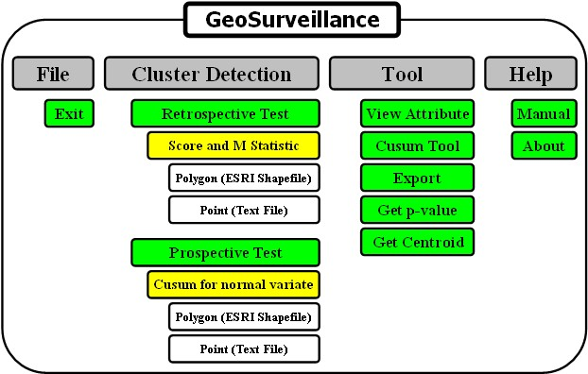
Figure 1. Hierarchical structure of GeoSurveillance

3. GIS functions in GeoSurveillance
GeoSurveillance provides basic GIS functions for interactive, display-related operations; these are accessed by the icons in the map window. Basic GIS functions for polygons (ESRI Shapefile) and points (Text File) are provided in different interfaces. Figure 2 shows icons and option buttons for basic GIS operations for each file format. Brief descriptions are presented below.

For ESRI Shapefile (Polygon)
①
②②
③
④
⑤
⑥
⑦
⑧
⑨
For Textfile (Point)
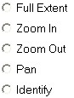
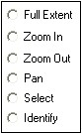

Figure 2. Icons for basic GIS operations (Shapefile: up; Textfile: down)

① Identify – display attribute information when clicking on map window
② Zoom in – magnify map
③ Zoom out – shrink map
④ Pan – move map
⑤ Pinpoint a subregion – highlight a local statistic corresponding to a clicked region; conditionally enable and highlight on a certain statistic
⑥ Show cusum in each subregion – shows cumulative sum chart for a clicked region during a given period; conditionally enable and highlight a univariate cusum statistic
⑦ Whole extent – show entire extent of map
⑧ Animation– animate map and table of global statistics over a range of bandwidths; conditionally enable and highlight a certain statistic
⑨ Get centroids – Calculate a series of polygon centroid coordinates

4. Data Format and Sample Dataset
In the current version of GeoSurveillance, ESRI Shapefiles for polygon data and Textfile for point data are supported. An ESRI shapefile is composed of three interrelated files: ***.shp, ***.shx and ***.dbf. These files come together to properly work in any commercial GIS software that supports the file format and they should have identical names. In the ***.dbf file, one record corresponds to one geographic entity in the ***.shp file, based on index information stored in the ***.shx file. In GeoSurveillance, there are two restrictions on the use of ESRI Shpaefile. One is the naming convention. The length of the file name should not exceed 9 characters, as shown below.
xxxxxxxx.shp, xxxxxxxx.shx, xxxxxxxx.dbf

maximum 8 characters

Another restriction is that any files residing on CD-Rom should be copied to the hard drive and the read-only check box in File – Property should be unchecked. These restrictions are expected to be eliminated in the next version.
For the purpose of demonstration, datasets of ESRI Shapefiles (polygon data) and Textfiles (point data) for both retrospective and prospective tests come with GeoSurveillance. Below is the list of the sample datasets, followed by brief descriptions.

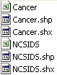
For retrospective tests
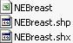
For prospective tests

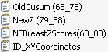
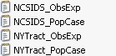
For retrospective test
For prospective test

Figure 3. Sample datasets (ESRI Shapefile (top), Textfile (bottom)

Shapefiles for retrospective tests
Cancer: For zip code districts in Erie County, New York
Observed number of breast cancer cases
Population
Zip code ID
NCSIDS: For counties in North Carolina
Observed number of Sudden Infant Death Syndrome (SIDS) cases (1974, 1979)
County name
Shapefiles for prospective tests
NEBreast: For counties in the northeastern region of the US
The number of breast cancer cases from 1968 to 1988
County name

Textfiles for retrospective tests
NCSIDS_ObsExp: For North Carolina counties
IDs
XY coordinates of county centroids
Observed number of SIDS cases in each county
Expected number of SIDS cases in each county
NCSIDS_PopCase: For North Carolina counties
IDs
XY coordinates of county centroids
Population in each county
Observed number of SIDS cases in each county
NYtract_ObsExp: For census tracts in New York state (Middle)
IDs
XY coordinates of census tract centroids
Observed number of breast cancer cases in each census tract
Expected number of breast cancer cases in each census tract
NYtract_PopCase: For census tracts in New York state (Middle)
IDs
XY coordinates of census tract centroids
Population in each census tract
Observed number of breast cancer cases in each census tract

Textfiles for prospective tests
IDXYCoordinates: For counties in the northeastern US
IDs
XY coordinates of county centroids
NewBreastZScores: For counties in the northeastern US
Z-scores from 1968 to 1998
OldCusum (6878): For counties in the northeastern US
Standardized normal cusum values from 1968 to 1978
NewZ(7998): For counties in the northeastern US
Z-values from 1979 to 1998

5. Spatial weight scheme
In GeoSurveillance, cluster detection analyses are performed in either a retrospective and prospective manner. For retrospective tests, the Score and M statistics provide a set of options for exploring both global and local spatial patterns over a range of scales. For the prospective case, the normal variate cusum statistic is used to detect spatial pattern change quickly. Z-scores in various forms are used as input variables in the prospective procedure. If desired, a set of spatially weighted z-scores [local Score and/or M statistic] can be exported from the Score and M statistic routines for use in the cusum statistic. For both the Score and M statistics, spatial weights are calculated based on Gaussian kernel weights. Details on spatial weights are explained in the next section.

5.1. Constructing the spatial weight matrix
In GeoSurveillance, the Gaussian weight function is used for constructing spatial weight matrices. It is formulated as follows:
; i, j=1,2,…,n
where $σ$ is the bandwidth determining smoothness and is the distance from location i to location j (e..g., the distance between regional centroids) . A is the area of the study region, and n is the number of subregions. The weights defined in this way are scaled so that $σ$=1 implies that most of the weight is given to subregions within a radius approximately equal to the average distance between centroids. Asincreases, more smoothing occurs and weights given to distant subregions start to increase. The weight matrix can be used in implementing the Score and the M statistic over a range of spatial scales.

5.2. Bandwidth
Two options for bandwidth specifications are given. One is a ‘single bandwidth’ option, where just one value of the bandwidth is input. Input is achieved by clicking on the Single Value option button and then typing in the textbox labeled sigma. Another option is ‘a range of bandwidths’, where the user inputs a series of bandwidths, and global statistical outcomes are given for each bandwidth automatically. Input is achieved by clicking on the A range of values option button and typing in textboxes labeled from, to, and by. For Example, in Figure 4, bandwidth starts from 0.2 and goes to 2.0 by intervals of 0.2. Depending on the phenomena under study, clustering may occur at certain spatial scales; these scales may be inferred by observing the corresponding bandwidths that generates the highest and most significant value of the global statistics. This detection is facilitated by providing a visual exploratory tool in the form of a figure:

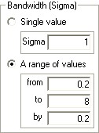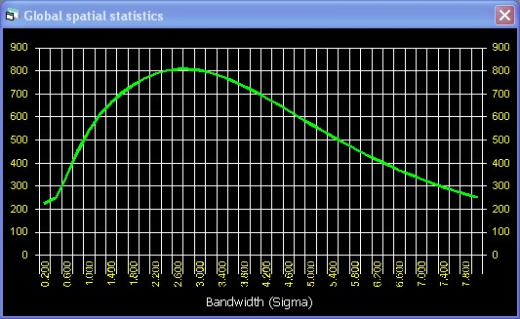
Figure 4. Illustration of bandwidth options

6. Cluster Detection – retrospective tests
For retrospective cluster detection, the Score and M statistics are provided; these are reviewed in sections 6.1 and 6.2. In section 6.3, the way the legend is built for map display is briefly explained. In section 6.4, illustration is made for both ESRI Shapefile (polygon data) and Textfile (point data) options.

6.1. The Score statistic
In GeoSurveillance, the Score statistic has two versions: (1) the unadjusted test and (2) the adjusted test. These are formulated as follows:

where, for example,
Alternatively, expectations for each region can be provided exogenously, based on not only population, but on other covariates as well. In addition,
where
The unadjusted statistic is identical to Tango’s (1995) global statistic. Unlike the unadjusted statistic, the adjusted has a denominator, in the expression. As the bandwidth approaches zero, the adjusted approaches the usual chi-square goodness-of-fit statistic (although should not be exactly zero since it is a denominator term in the Gaussian spatial weight scheme). The diagonal elements of the spatial weight approach one and the off-diagonal elements come close to zero when the bandwidth, sigma, approaches zero. In GeoSurveillance, the spatial weight matrix becomes the identity matrix when a value of zero is input for the value, so that the aspatial case can be consistently calculated in the adjusted scheme of the statistic.
Following Tango (1995) and Rogerson (1999), approximations of the p-value associated with the unadjusted statistic using normal and chi-square approximations are as follows:

For the adjusted statistic, the approximation is differs only in the A matrix; the normal and chi-square approximations are as follows:
For the adjusted statistic, the degrees of freedom gets close to n-1 as approaches zero. This is consistent with the degrees of freedom in the aspatial chi-square goodness-of-fit test. On the other hand, as increases, gets to close to 1, indicating that the correlations between local statistics become stronger.

6.2. The M statistic
Following Rogerson (2001), the M statistic is formulated as follows:
where is the Gaussian weight between subregion i and j and is a normal variate in subregion j. The local M statistic (denoted) is the spatially weighted z-score in a locality, i. GeoSurveillance uses three different ways of transforming to , based on (observed value in subregion j) and (expected value in subregion j) as follows:

Options for calculating the M statistic based on the three transformations are provided in the user interface. Note that the ‘Poisson Method’ for z-score transformations is consistent with the components in the adjusted global Score statistic:
Therefore, the local Score statistic becomes the M statistic when adjusted by. In the Score statistic, is one component of spatial weight, whereas it is an element of the z-score defined in the Poisson method. In essence, however, the adjusted local score statistic, and the derived from the Poisson method are the identical quantity. For this reason, GeoSurveillance integrates the two variables (Adjusted and Poisson) into one option.
Finally, the M statistic has a critical value under the null hypothesis of no clustering that is denoted by M*. The critical value, M* is (Rogerson 2001):

where is the chosen probability of rejecting a true null hypothesis. In GeoSurveillance, values of 0.05 and 0.01 are selectable. By default, 0.05 is set when the user interface appears. is the bandwidth that denotes the level of spatual smoothing among observed z-values as determined by the Gaussian spatial weights, and is the number of subregions.
Figure 5 shows the user interface of the retrospective cluster detection tests (the Score and the M statistics) for polygon shapefile data. In this panel, z-value options, the bandwidthand ranges, and alpha values are all interfaced so that tests of spatial pattern are made possible interactively. Results are displayed in the local pattern and global pattern summary windows. Furthermore, the summary windows are linked to the map display so that text information pertaining to the spatial pattern can be visually checked out in the map window.
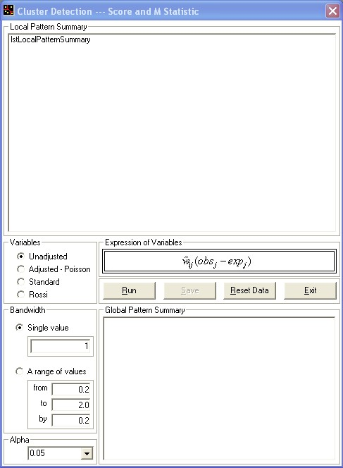
Local pattern summary - - - > the local statistic for each subregion is displayed here. By clicking on a row in this list box, the corresponding subregion is highlighted yellow in the map window. By clicking on the Save button when Single value in Bandwidth is selected, the information of local spatial pattern of all the subregions is saved in a text file along with corresponding IDs.
Global pattern summary - - - > Text information for the global spatial pattern(s) is displayed for both single and range values of bandwidth in this list box. By clicking on a list item in this box when A range of values is selected, a local pattern map is displayed in the map window linked to this list box. Animation of local pattern map is also possible by clicking on the animation tool button in the map.
Figure. 5. Panel for the retrospective cluster detection tests (the Score and the M statistic)
In the Variables box, the corresponding z-value is selected for computing either the Score or the M statistic. The second option in the Variables is Adjusted – Poisson. As noted previously, the adjusted Score statistic and the M statistic based on the Poisson z-score transformation method are identical quantities. Thus, the two options are tied together in the variable selection interface. In the Bandwidth (sigma) box, bandwidth range can be defined by setting start, end, and interval information in the from, to, and by text boxes.
As noted previously, when the single sigma value is zero, the Gaussian weight matrix converges to the identity matrix. This is equivalent to the result when spatial weights are not applied to the selected z-value variables.
Alpha is set to 0.05 by default. 0.01 is also selectable by clicking on the Alpha box. The results can be saved in a text file based on the combination of options selected. For example, if Standard option in the Variables and Single value in the Bandwidth (Sigma) are selected, the saved result will be local statistics along with the IDs of the corresponding subregions.

6.3. Legend and mapping
In the legend and map displays, the local Score and M statistics are compared with the predefined critical threshold values. In the case of the Score statistics, category endpoints are defined as zero, one-third and two-thirds of the maximum and minimum values. For the M statistic, threshold values are defined based upon the critical value (M*). Figures 6 and 7 show how the Score and the M statistic are categorized for the legend display in GeoSurveillance.
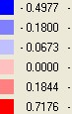
Dark Red
Red
Light Red
Light Blue
Blue
Dark Blue
0
(1/3) max

(2/3) max

(-1/3) min
(-2/3) min
Figure 6. Definition of category cutoffs for the legend of the Score statistic

0
0.5×M*
+M*
-0.5×M*
-M*
Dark Red
Red
Light Red
Light Blue
Blue
Dark Blue
Figure. 7. Definition of category cutoffs for the M statistic

6.4. Illustration of the Score and the M statistic
In this section, step-by-step demonstration will be made described, for quick understanding of GeoSurveillance. The NCSIDS shapefile will be used for polygon data and NCSIDS_PopCase Textfile will be illustrated for point data. Detailed illustration will be made only for the polygon shapefile. Due to similarities, illustration for point data will be made only briefly. As an example, the Adjusted – Poisson option will be illustrated for the Single value in Bandwidth (Sigma), using Alpha = 0.05 (default). For a sigma range, a range of sigma values from 0.2 to 4 by 0.2 will be illustrated. Users can experiment various combinations of parameters, statistic, bandwidth, and so on for spatial data exploration.

6.4.1. Illustration for a single value sigma
1) Open ESRI Shapefile by Clicking Cluster Detection – Retrospective Test – Score and M Statistic – Polygon (ESRI Shapefile) in the menu. The Open dialog box appears for loading the ESRI Shapefile into GeoSurveillance.
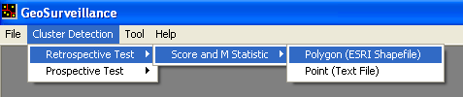
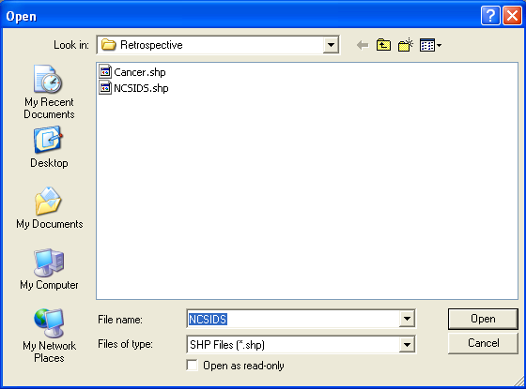

2) Select NCSIDS shapefile. Then, the Data Input form appears.
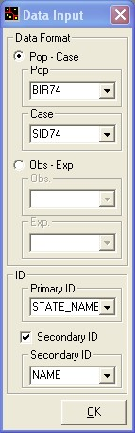
3) Select Pop – Case option, and select BIR74 and SID74, in Data Format, and STATE_NAME and Name in Primary ID and Secondary ID, respectively. Click the OK button. Then, the map window and experimental panel appears.
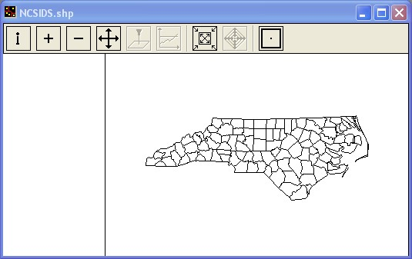
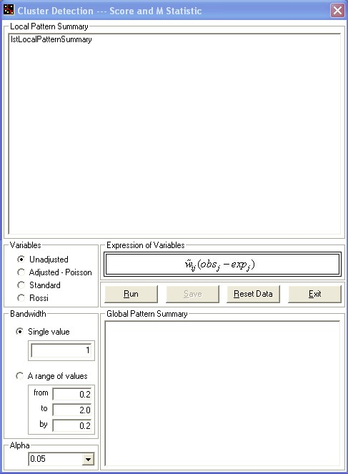
4) Check Adjusted-Poisson option in the Variables frame and click the Run button. Results for the selected options are mapped and tabulated in the local and global pattern summary windows. The local pattern summary lists two IDs, local Score statistics (), and z-values.
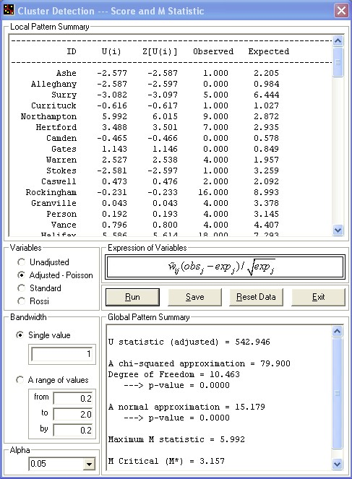
In the global pattern summary, the adjusted global Score statistic is displayed along with chi-square and z-score approximations, the degrees of freedom, the maximum M statistic, and the critical M value (M*). By clicking on the list item in the local pattern summary table, the linked subregion in the map is highlighted as yellow. Or, by pinpointing the subregion with the icon  pressed, the list item linked is highlighted.
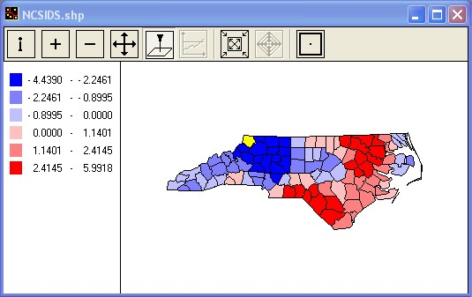

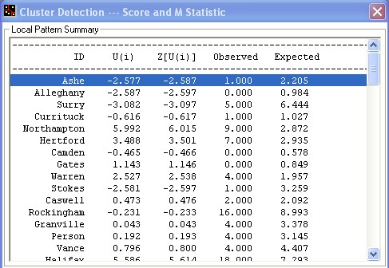
Notably, by inputting zero in the single bandwidth text box, the global Score statistic becomes the chi-square approximation and the degrees of freedom converges to n-1, where n is the number of subregions (observations). Recalling the definition of the adjusted Score statistic, this is what is expected since the spatial weight matrix converges to the identity matrix as sigma approaches zero. On the other hand, if a large bandwidth is input in the single bandwidth text box, the degrees of freedom approaches one. For example, the degrees of freedom is 10.46 when sigma is one. When sigma becomes larger, say 10 (implying a standard deviation of the Gaussian kernel equal to a length of approximately 10 average-sized regions), the degrees of freedom is 1.27.

5) By clicking the Save button, results can be saved as a text file, as indicated below.
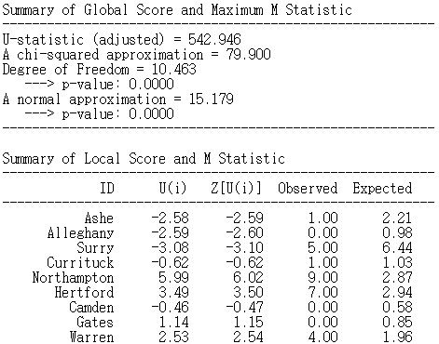

6.4.2. Illustration for a range of sigma values
1) Repeat through step 3 in the Illustration for a single value sigma section.

2) Select the Adjusted – Poisson option, A range of values option, and set Alpha = 0.05.

3) Input the range of bandwidth as from 0.2 to 4 by 0.2 in each corresponding text box.

4) Click on the Run button. Nothing appears in the local pattern summary table. The results are shown only in the global pattern summary table, as shown below. The global pattern table lists the bandwidth (sigma), the global Score statistic, the chi-square approximation and associated degrees of freedom, the maximum M statistic, the critical M statistic (M*), and the p-value for the global Score statistic.

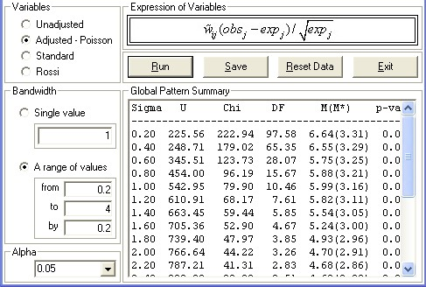
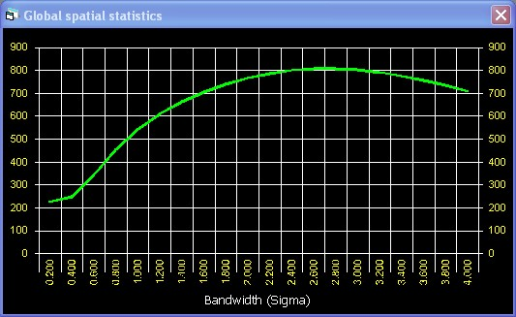

5) If an item is clicked in the global summary table, the local statistics for the selected bandwidth are mapped in the map window.
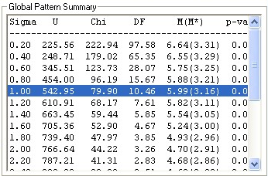
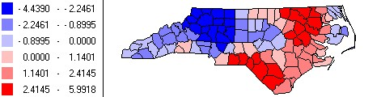

6) By clicking on the Animation on bandwidth icon (left figure below) in the map window, the map is animated over the range of sigma values. After the animation finishes, a slider bar appears in the map window (right figure below).
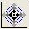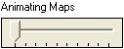
This is for locating the bandwidth and showing the linked local pattern in the map window. Using this slider bar, a local pattern map for a sigma within the sigma range can be shown interactively. This can also be accomplished by clicking on the list item corresponding to the desired bandwidth in the global summary table.

7) By clicking the Save button, the results can be saved in a text file. This text file contains information identical to the global pattern summary table.

6.4.3. Illustration for point data (textfile)
Due to the similarity of interfaces and procedures, illustration of point data will be made by briefly describing the procedure and showing the interfaces below.

1) Click Cluster Detection – Retrospective Statistic – Score and M Statistic – Point (Text File) in the menu.
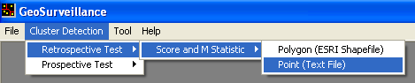
Then, the panel for textfile point data appears:.
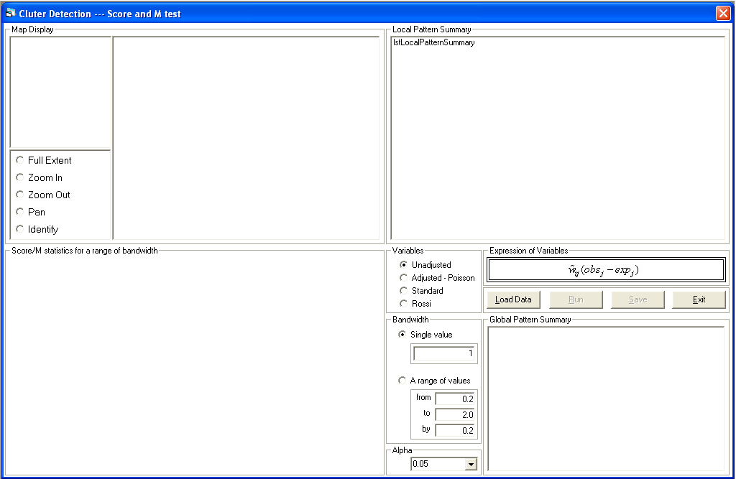

2) By clicking on the Load Data button, the Data Type selection box appears so that users can select the data type. Click Population – Case option and click Continue.
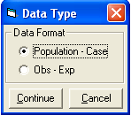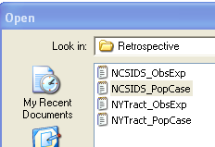

3) Select NCSIDS_PopCase textfile in the open dialogue box. Although nothing seems to happen, data is loaded into the program. After setting variable, and bandwidth options and clicking the Run button, the results appear:.
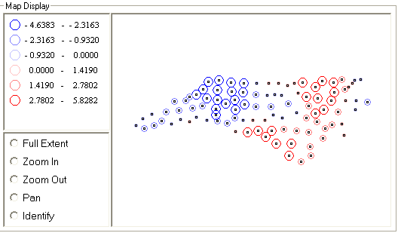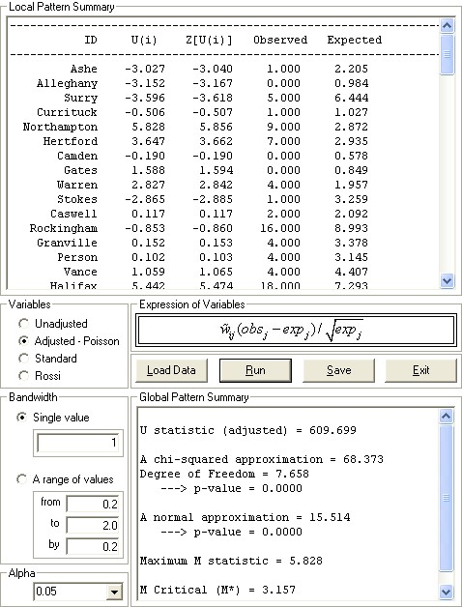
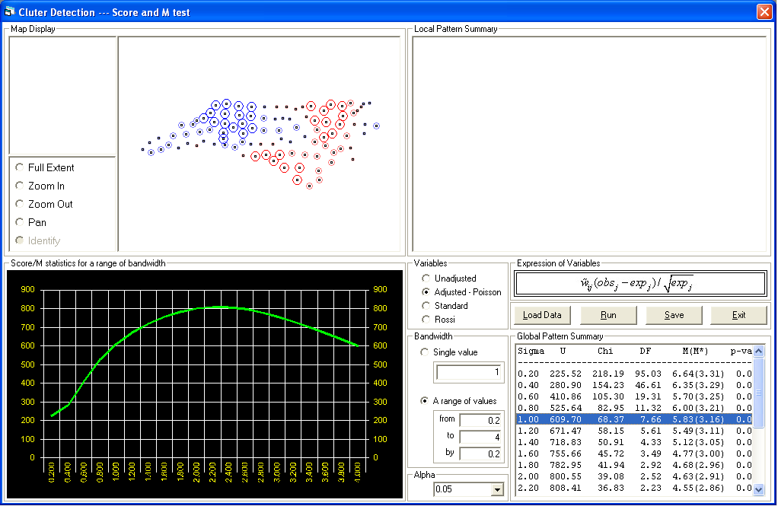
For textfile point data, the map display is different from that of shapefiles. Legend schemes are the same, and GIS functions can be applied based on the option button selected. For a range of sigma, the figure is shown at the bottom-left of the panel. Results can be saved in the same manner as with the polygon data case.

7. Cluster Detection – prospective tests

7.1. Definition of the cumulative sum statistic
In the current version, only the univariate cumulative sum (cusum) is implemented. The univariate cusum statistic is defined as:
This statistic is based on a z-score at time t, and a parameter k. There is another parameter h that is a critical threshold value for signals. If a z-score at time t-1 exceeds the parameter k, it is cumulated as a contributor to change in the mean value. When the accumulated value exceeds the threshold value h, it indicates that the overall mean has shifted significantly. The parameters can be input by the user in the interface.

7.2. Period setting
Prospective tests in GeoSurveillance require a set of columns (fields) that represent z-scores over time, where each column (field) corresponds to the temporal unit for monitoring. For shapefile polygon data, monitoring periods need to be specified in such a way that the user selects the column names corresponding to the start and end time. For textfile point data, a textfile containing a set of columns representing temporal units for monitoring is required. GeoSurveillance automatically deals with the temporal periods using the information in the first and last column for labeling.

7.2.1. For shapefile polygon data
In shapefile polygon data, a set of fields should be ordered in temporal sequence in the dbf file. For example, suppose that the prefix of the field name is set to CS and the start and end time is 1978 and 1988, respectively. Then, the sequential field names are CS78, CS79, . . . CS88, and the field names are automatically searched in the database (dbf file) and the z-values of all the subregions from each corresponding time field are read.
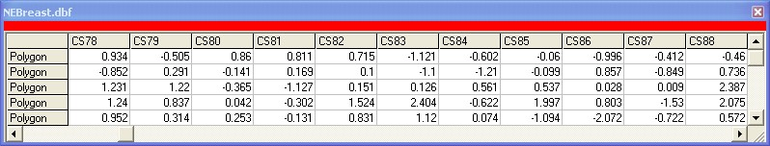

Figure 8. Illustration of sequential fields of z-scores

In Figure 8, the common field name is CS and time is sequentially ordered from 78 to 88. The period in the field name increases by one unit each time period (year). The program automatically increases the period in the field name by one. If, say, starting from CS78, then CS79 (CS + 78+1) is internally defined and automatically searched as the field name of the next time period. This continues until the end period is reached. Labels in the chart and summary tables in GeoSurveillance are generated through this mechanism. If the actual data is incorrectly prepared and looks like, e.g., CS78 CS79 CS79 CS79 CS79 CS79 CS79 CS79 CS79 CS88, GeoSurveillance generates an error, since it cannot find the fields of CS80 CS81 CS82 CS83 CS84 CS85 CS86 CS87 due to misspecification of the time period.

7.2.2. For textfile point data
With textfile point data, two textfiles (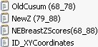,) are necessary. The first one (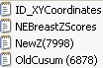) contains two columns representing ID, and X-Y coordinates, and the second one () contains a set of z-values over time periods. Since the periods are predetermined in the second textfile, the user does not need to specify the monitoring period in GeoSurveillance. Instead, the monitoring periods should be considered in preparation of the second textfile (). For example, may include the periods from 1968 to 1988. An additional textfile () is required if the cusum start is not zero. For example, is assumed to include the cusum values from 1968 to 1978 which are previous periods for all the subregions. If the user continues to monitor from 1979 to 1988 based on the previously accumulated values, needs to be input, instead of which contains, say, periods from 1968 to 1998. The prospective test operates based on this mechanism for the two start options. For labeling time in figures and tables, GeoSurveillance automatically starts from 1 and goes to the number of monitoring periods. For start options, details will be explained in next section.

7.3. Cusum options
There are two cusum options available in the current version -- Zero and Previous. Recalling the definition of the cusum, , for the Zero option is zero, whereas for the Previous option, the initial cusum starts from the previously calculated value in the previously saved cusum file (denoted as ***.csm for shapefile polygon data or ***.txt for textfile point data). A ***..csm file can be generated in GeoSurveillance for shapefile polygon data. For textfile point data, previous cusum values can be saved in a ***.txt file. Then, $S_{0}$comes from the last column that was stored in the ***.csm or ***.txt file.
7.4. Parameter Setting
There are three parameters that the user can input in GeoSurveillance. The k and h values are explained above. Bandwidth may also be set. This is useful for considering the possibility of emergent clusters on scales greater than that of individual regions. The default value for the bandwidth is zero, and this assumes that the observed z-scores in all subregions are independent. The user can explore the effect of spatial effects on the cusum values by changing the size of bandwidth.

7.5. Animation speed
The results of the univariate cusum statistic are animated with figures, maps and tables. The program provides three options for animation speed that the user can control as Fast, Medium, and Slow. By default, this option is set to Fast.

7.6. Illustration
In this section, the cusum procedure in GeoSurveillance will be illustrated using NEBreast shapefile for polygon data, and a couple of textfiles (ID_XYCoordinates.txt, NEBreastZScores (68_88).txt, OldCusum (68_78).txt, NewZ (79_88).txt).

7.6.1. Illustration of shapefile polygon data
1) Open Shapefile polygon data.
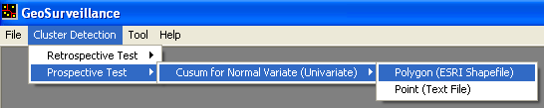

2) Select NEBreast.shp in the open dialog box. Click on Open. Then, Select Name Fields panel appears so that IDs can be set for the use of labeling later. Select Name field and click on OK button.
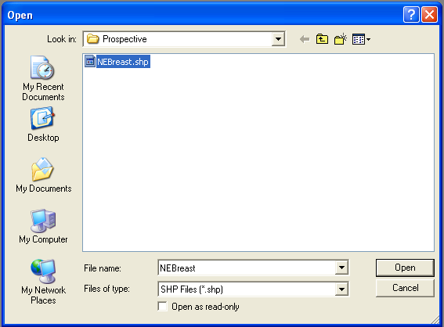
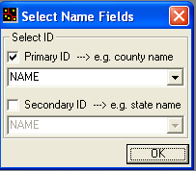

3) The univariate cusum test panel appears, as below. Select monitoring periods by setting CS68 and CS88 as start and end period. Set the critical threshold at an h-value of 8.1 (this particular choice for this multiregional example corresponds to an overall false alarm rate of one for every hundred time periods). Keep others choices at their default values. Click on the Run button. Then, animation of figures, tables, and maps starts.
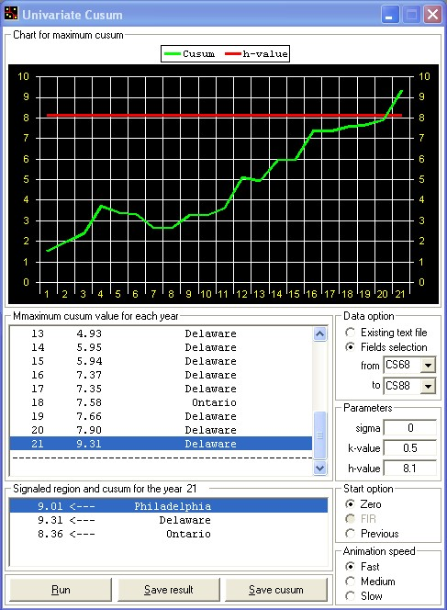

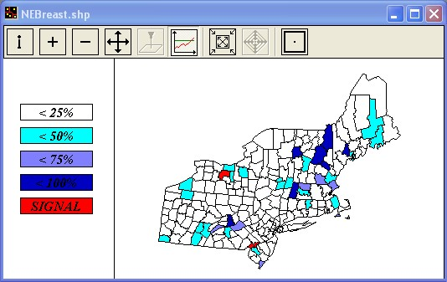
The Maximum cusum value for each year table lists the maximum cusum value and the corresponding subregion observed in each year. The legend for the cusum is constructed based on the threshold (h-value). 25%, 50%, 75% and 100% of the h-value are the class cutoff values used for coloring the map. If the cusum value of a subregion exceeds the h-value itself, the subregion is colored red. Figure 28 shows the legend colors.

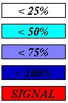

Those regions that exceed h (green line in the chart in Figure 29) in each year will be listed in the Signaled Region and cusum for the year table. If no region has a cusum value greater than the critical value, nothing is listed in the Signaled Region and cusum for the year table. By clicking the signaled region in the Signaled Region and cusum for the year table, the linked region will be highlighted red, and the figure that shows the cusum pattern of the highlighted region for the periods appears in the bottom left panel of GeoSurveillance.
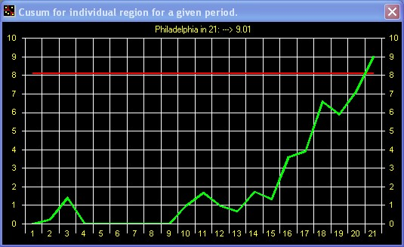
By clicking the Show cusum in each subregion tool button 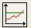 and clicking a subregion on the map, the cusum chart corresponding to the selected subregion appears.

4) By clicking on the Save Result button, the results can be saved as a text file for reporting. If no operation is performed, the Save Result button will not be activated.
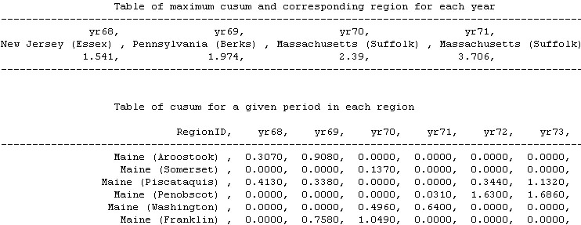
5) Click on the Previous button in Start option and click the Run button. A dialog box appears in the lower left part of the window. Click the Open button and select 68_78.csm. This 68_78.csm file is prepared in advance. This file can be generated using the Save cusum button, which is activated after the cusum operation for a given period is finished. In this case, periods were set from CS68 to CS78 and saved as 68_78.csm file so that it can be used for providing the starting base of previously calculated z-scores.
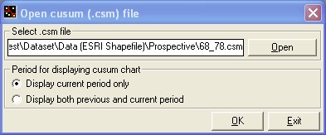
Set the start and end periods as CS79 and CS88, respectively in Data option so that monitoring periods can be continuous. The last column of the 68_78.csm file provides the starting values of new periods for CS79 through CS88. Click the Ok button. If Display current period only option is selected, the figure shows only the new cusum values starting from the previous ones. If Display both previous and current periods option is selected, both previous and new cusum values are displayed.
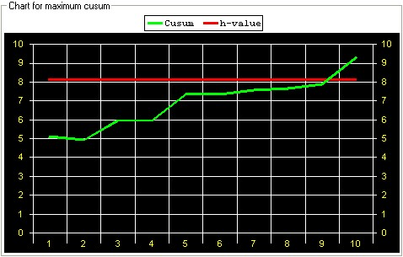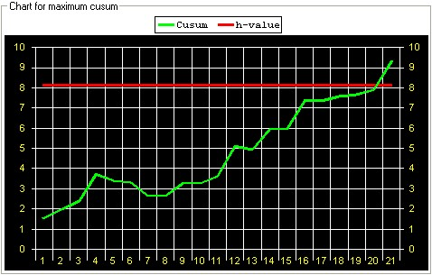

7.6.1. Illustration of textfile point data
1) Open textfile point data.
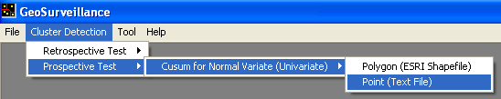
Then, cusum panel for point data appears as below.
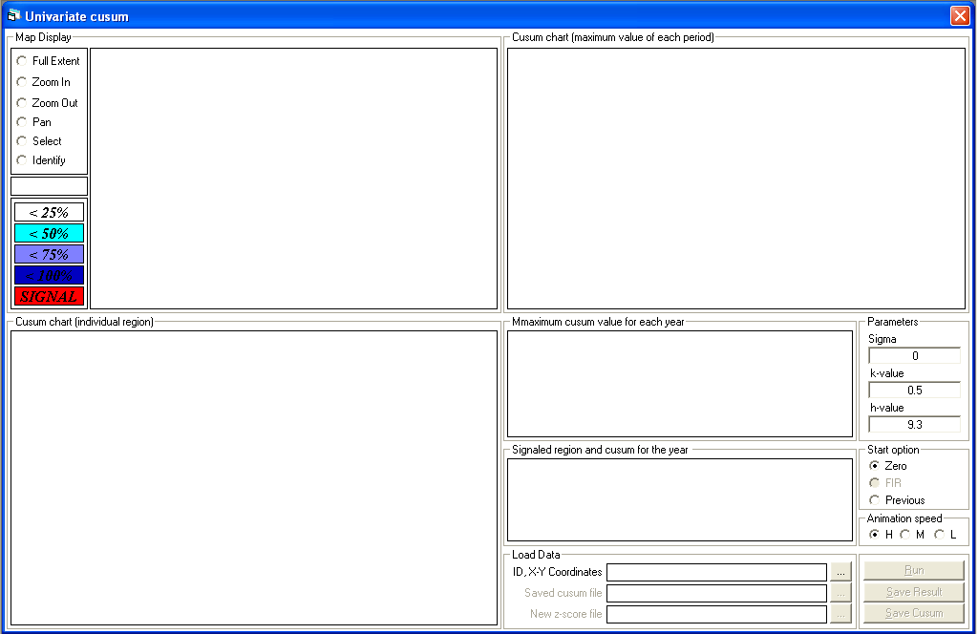
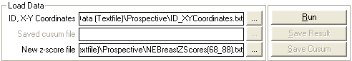

2) Click on … button for ID, and X-Y Coordinates. Select ‘ID_XYCoordinates.txt’ file. Then, activated is … for New z-score file. Click the activated button and select ‘NEBreastZScores.txt’ file. Then, the Run button is activated. After setting h as 8.1 in Parameter, click on the Run button. Animation of chart, table and map starts. The map is linked to the figure and table. Basic GIS functions for the map are provided. The legend scheme is the same as with the polygon dataset case. By clicking on the item in ‘Maximum cusum value for each year’ list box, the signaled regions are listed in ‘Signaled region and cusum for the year’ list box. By clicking on the item in the ‘Signaled region and cusum for the year’ list box, corresponding region is highlighted by green circle in the map, along with the cusum chart for the region on a given periods.
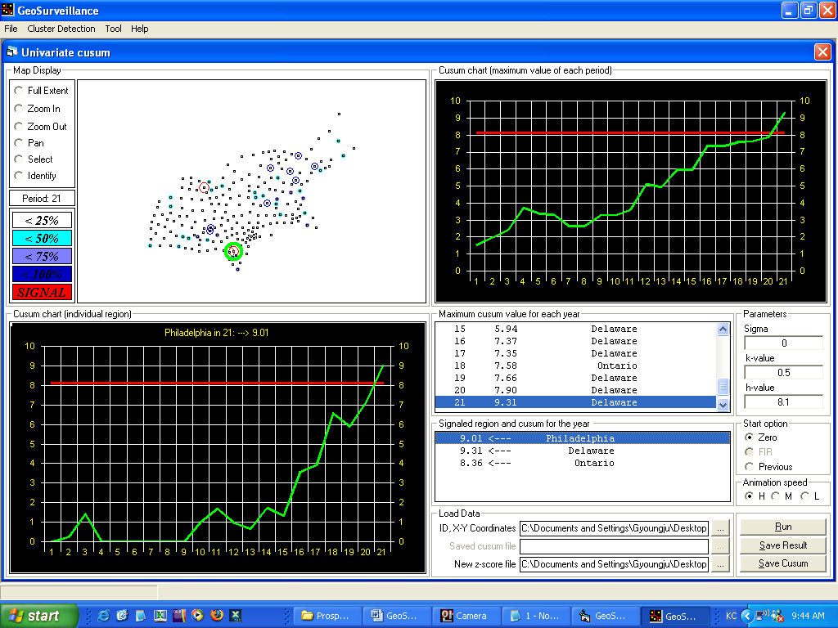
The cusum values are classified based on the legend scheme by different color and size of the corresponding circles.

3) To illustrate the Previous start option, click on Previous option button in Start option. Then, click on the first activated … buttons and select ‘ID_XYCoordinates.txt’ file. Click on the second activated … button and select ‘OldCusum (68_78).txt’ file. This file is prepared as a set of cusum values for the specified periods (1968~1978) in advance. This can be generated in the same manner as with the polygon shapefile case. Once previous cusum values are loaded, new cusum values continue to be monitored by clicking the third activated … button and by loading ‘NewZ (79_88).txt’ file.

4) Click on the Run button. Then, the figure for the previous cusum is instantly drawn and only the new periods are animated, based on the animation speed that the user specified.

5) Results can be saved for reporting by clicking on Save Result button.

8. Other Tools
There are other tools provided to help the user analyze spatial data more conveniently. In this section, these tools are illustrated.

8.1. View attribute of ESRI shapefile
When the ESRI shape file is opened, attribute values are automatically loaded from the ***.dbf relational database file. Accordingly, this menu is activated only when the shape file is opened. In GeoSurveillance, attributes in the ***.dbf file are displayed in tabulated form as shown in Figure 9. Currently, this tool only displays attributes. Any editing tools are not provided.
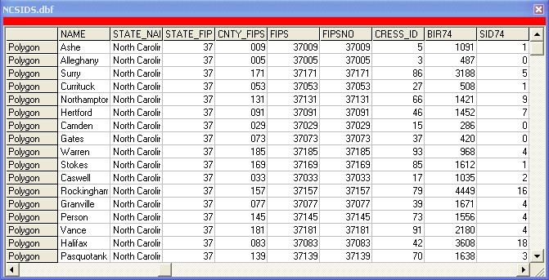
Figure 9. Illustration of displaying shapefile attributes information

8.2. Cusum Tool
By default, k and h are set to ½ and 9.3 respectively in the cusum panel. The user can calculate the parameters to modify them interactively at any time. Cusum Tool provides a convenient interface of obtaining the parameters.

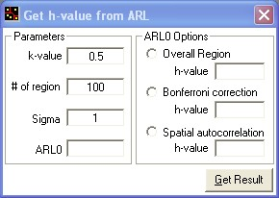

ARL₀ is the in-control average run length and h can be automatically calculated by specifying the desired average run length between false alarms (ARL₀) in the text input box in various ways. Using the ARL₀ value, an h value for Overall Region option is approximated using the formula below.

For a Bonferroni correction option, ARL₀ × the number of subregions is used in the above approximation, instead of ARL₀, to account for multiple testing. For the Spatial Autocorrelation option, ARL₀ is adjusted as ARL₀× the number of subregion / (1+0.81) to account for the spatial autocorrelation among local statistics. is the bandwidth that is required for calculating Spatial Autocorrelation option and can be input in the text box labelled sigma in the cusum analysis panel.

8.3. Export
To obtain z-scores using observed and expected data for a set of periods, GeoSurveillance provides an Export tool. This tool is activated when the shapefile polygon data is loaded. Data need to contain a set of observed and expected counts for each period to convert corresponding z-scores based on the Poisson, Standard, or Rossi methods explained previously. By clicking on the Export button, a textfile containing a set of converted z-values over time is generated and can be saved.
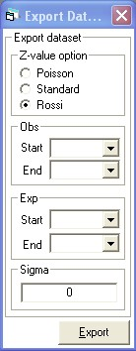

8.4. Get p-value
Another tool calculates p-values. In GeoSurveillance, p-values for two kinds of statistics can be computed -- z-scores and chi-square statistics. In the case of z-scores, the user should specify the z-score in the z-value text box. By clicking the Calculate button, the p-value for the input is calculated and shown in grey-colored textbox. The user can carry out copy-paste operations through this display textbox (Figure 10). The z-score is calculated by numerical integration of the standardized normal distribution function and the precision of result is to eight decimals. In the case of the chi-square statistic, the user inputs both the chi-square statistic and degrees of freedom. It should be noted that the p-value for the chi-square statistic is based on the approximated Gamma function in the chi-square statistic. This generates a relatively precise approximation for integer degrees of freedom. For non-integer degrees of freedom, this approximation is not precise. Therefore, the p-value calculation for the chi-square statistic should play a role as just an auxiliary tool.
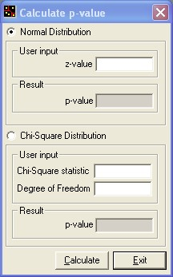
Figure 10. p-value calculator

8.3. Get centroid
If an ESRI polygon shapefile is opened, the centroids of polygons can be computed and saved as a text file for further use in other GIS software packages. The x-y coordinates of centroids are computed as centers of mass using:

$$C_{x}=\sum_{i=1}^{n−1}{\frac{(X_{i}+X_{i+1})(X_{i+1}Y_{i}−X_{i}Y_{i+1})}{6A}}, C_{y}=\sum_{i=1}^{n−1}{\frac{(Y_{i}+Y_{i+1})(X_{i+1}Y_{i}−X_{i}Y_{i+1})}{6A}}$$

is the area of a given polygon and n is the number of points comprising the polygon. $X_{i}$and$Y_{i}$are x-y coordinates of point i in a polygon. is computed using the formula below:
$$\text{polygon area }A=\sum_{i=1}^{n}{\frac{(X_{i+1}−X_{i})(Y_{i+1}−Y_{i})}{2}}$$

In GeoSurveillance, two interfaces for doing this operation are provided. If you click the tool button , red dots representing centroids are displayed in the polygon shapefile map window. By clicking the Get Centroid menu, the centroids are saved as a text file.

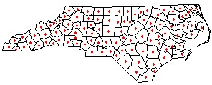
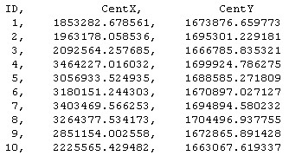

9. Help
9.1. Manual
By clicking this, the message below appears.
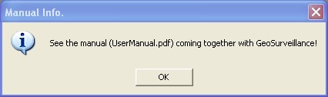

9.2. About GeoSurveillance
By clicking this, contents of copyright, logo, etc appear as below.
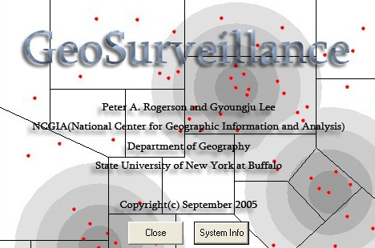

References

Besag, J. and Newell, J. 1991. The detection of clusters in rare diseases. Journal of the Royal Statistical Society Series A, 154: 143-55.
Hawkins, D.M. and Olwell, D.H. 1998. Cumulative sum charts and charting for quality improvement. New York: Springer-Verlag.
Lawson , A. 2001. Statistical methods in spatial epidemiology. New York: Wiley.
Waller, L. and Gotway, C. 2004. Applied spatial statistics for public health data. New York: Wiley.

Rogerson, P.A. (1999). The Detection of Clusters Using a Spatial Version of the Chi-Square Goodness-of-Fit Statistic. Geographical Analysis, Vol. 31, No. 1.

Rogerson, P.A. (2001). A Statistical Method for the Detection of Geographic Clustering. Geographical Analysis, Vol. 33, No. 3.

Rogerson, P.A. (2001). Spatial monitoring of geographic patterns: an application to crime analysis. Computers, Environment and Urban Systems, Vol. 25, 539-556

