Aspect vs. relative tense: The case reopened*
Jürgen Bohnemeyer, University at Buffalo – SUNY

1. Klein’s Conjecture
The question examined in this article is whether viewpoint aspects and Reichenbachian relative tenses are distinct semantic categories. Informally, viewpoint aspects constrain event descriptions such that they are interpreted from a particular temporal reference time, during which they are ongoing, completed, or in a pre- or post-state (further options are sometimes considered). Relative tenses in turn constrain the time interval during which the described eventuality occurs in terms of its temporal order with respect to a reference time (as opposed to the utterance time, which is the function of absolute or deictic tenses). Given these informal characterizations, it is not obvious that the two notions describe distinct phenomena, and what I shall call Klein’s Conjecture says that they in fact do not. Klein’s Conjecture states that within the theory of tense and aspect proposed in Klein 1994 (see section 2 for a sketch), the phenomena traditionally treated as relative tenses can be analyzed as viewpoint aspects.

“I think that relative tenses are a combination of tense and aspect. (...) The notion of relative tense is not necessary to account for the pluperfect nor for the future perfect. We could surely use the label ‘relative tense’ instead of ‘aspect’ here. But then, we would also be forced to call the contrast between imperfective and perfective a difference in relative tense, and this does not seem to be a particularly fortunate choice of terms.” (Klein 1994: 131)

A more precise formulation of Klein’s Conjecture is proposed in section 3. According to Klein’s Conjecture, relative past tenses are really better analyzed as perfect aspects. Thus, the common denominator of the English perfect tenses is not anterior tense, locating an event in the relative past of some reference point, but perfect aspect, locating the ‘topic time’ of the utterance – the time about which it makes an assertion, asks a question, etc. – in an interval following the time of the event. Traditionally, the pluperfect is considered polysemous between an aspect-like ‘perfect-in-the-past’ reading and a tense-like ‘past-in-the-past’ reading (Jespersen 1924; Comrie 1976; cf. section 4). In (1)-(2), the difference can be pinpointed with respect to the time adverbial. Under the aspectual reading of the pluperfect in (1), the adverbial denotes a time at which Bill is presented as being in the result state of the arriving event, whereas under the anterior-tense reading in (2), the adverbial denotes the time at which Bill left. Klein attributes these different interpretations not to polysemy of the pluperfect, but to underspecification of the time adverbial, which specifies the topic time in (1), but the event time in (2) (cf. Klein 1992).

(1) Bill had arrived at six o’clock. I arrived at six sharp, and he was already half done with his meal, so he must have gotten there a lot earlier.
(2) Bill had arrived at six o’clock and had left again at seven. The inspector did not get there until eight. (Comrie 1976: 56)

In this article, I present evidence from English, Japanese, Kituba, Kalaallisut (or West Greenlandic), Korean, and Yucatec Maya that casts doubt on the validity of Klein’s Conjecture. In English, the pluperfect and future perfect pass standard polysemy tests. In the other five languages the study draws on, the aspectual and relative tense meanings that are conflated in the English pluperfect and future perfect on the polysemous analysis are expressed separately. In Kalaallisut and Yucatec, renditions of ‘Bill had arrived at six o’clock’ are compatible only with interpretations such as the one in (1), in which at six o’clock is a reference/topic time adverbial, not with interpretations of the kind illustrated by (2), in which at six o’clock is understood as an event time adverbial. Yucatec also has a prospective aspect that functions like a mirror image of a perfect aspect, placing the topic time inside the runtime of a pre-state of the event described by the verb.
In contrast, Japanese, Kituba, and Korean have expressions of ‘Bill had arrived at six o’clock’ that occur in contexts such as (2) but not in those of type (1). I propose that the former are pure perfect aspects, which place the topic time (or rather what Klein calls the ‘topic time projection range’ – the possible time interval in which the actual topic time of the utterance must fall) inside the run time of some post state caused by the event described by the verb stem. In contrast, Japanese, and Kituba have pure relative past (i.e., anterior) tenses. Unlike perfect aspects, these do not shift the topic time (projection range) to a time after the described event and thus do not permit topic time adverbials in cases where the event time is not included in the topic time. To obtain the post-state aspect readings, such anterior tenses may be combined with perfect aspects. And Korean has a pluperfect which like its English equivalent has an interpretation that involves a combination of deictic and anaphoric anteriority, but which unlike the English pluperfect lacks a perfect-in-the-past interpretation.
The typological evidence strongly suggests that true perfect aspects and true anterior tenses exist in the languages of the world and have distinct semantic properties. This aligns with the evidence from ambiguity tests suggesting that the English pluperfect and future perfect are polysemous between aspectual and tense interpretations (and, presumably, only the aspectual reading is compositional). How would Klein’s theory have to be modified so as to be able to account for this data? First of all, anaphoric tenses relate topic times, not to utterance times in particular, but to reference times more generally, of which utterance times are merely a special case, but which may also be anaphorically tracked from surrounding discourse, like Reichenbachian reference points, and perhaps even determined by matrix clauses in sequence-of-tense phenomena (similarly Stowell 2007). In complex tenses comprising both a deictic and an anaphoric component, such as the English pluperfect on its non-aspectual interpretation, the value of the topic time variable is constrained vis-à-vis both utterance time and some other contextualized reference time simultaneously. It follows that in order to accommodate anaphoric and complex tenses, Klein’s theory must recognize Reichenbachian reference points distinct from (other) topic times. Secondly, the tense component of the theory would have to be extended to capture, in addition to constraints on the relation between topic time and utterance time expressed by absolute/deictic tenses, constraints on the relation between topic time and a variety of reference points expressed by relative/anaphoric tenses. And, finally, the purely time-relational treatment of viewpoint aspect in terms of temporal relations between topic time (projection range) and event time would have to be augmented by a mereological approach that distinguishes temporal relations between topic time (projection range) and the run times of various parts of a causal chain in which the event described by the verb is embedded: topic time may be inside the runtime of the described event (imperfective) or a post- (perfect) or pre-state (prospective) of the event or it may include the event itself (perfective) or its initial (ingressive) or terminal boundary (egressive). This is based on an event ontology in which all events are assumed to be preceded by such causal pre-states and followed by result states, although verbs and other lexical event descriptors may not refer to these states unless the description in question is in fact a state change description (cf. Smith 1991: 33-36 and references therein; Bohnemeyer 2002: 38-44).
The paper is organized as follows: section 2 summarizes the basic assumptions of Klein’s theory and introduces a standard formalization. Section 3 provides and discusses a more explicit formulation of Klein’s conjecture. Section 4 contrasts the traditional polysemous analysis of the English perfect with Klein’s monosemous account and provides the evidence for polysemy. The following sections present the evidence for pure perfect (and prospective) aspects (section 4) and pure relative tenses (section 5). Section 6 discusses Korean –essess as a deictic-anaphoric hybrid tense. Section 7 then proposes the “upgrades” to Klein’s theory that would allow it to accommodate the evidence presented in sections 3-5. Section 8 concludes.

2. Klein’s theory
Klein (1992, 1994) breaks with almost the entire tradition by proposing that (deictic or ‘absolute’) tenses relate utterance times, not to event times, but to what Klein calls topic times. These are in turn related to event times via an independent second functional category, which Klein identifies as aspect. In the terminology of Smith 1991, Klein’s ‘aspect’ is viewpoint aspect, rather than situation aspect – a classification of the temporal properties of situation/eventuality type descriptors – which Klein calls ‘aktionsart’. Other authors use ‘grammatical aspect’ for what Klein means by ‘aspect’ and ‘lexical aspect’ for Klein’s ‘aktionsart’. Tense and aspect categories are semantic categories that may – but need not – be expressed by inflections and/or function words by themselves or in language-specific packages with other tense/aspect categories, but that are always involved in the temporal interpretation of natural language utterances even if these utterances contain no expression of them.
There is a structural similarity between Klein’s proposal and neo-Reichenbachian approaches such as Declerck 1991, Hornstein 1990, and Ogihara 1996. Figure 1 matches the components of Reichenbach’s (1947) model of tense semantics to their counterparts in Klein’s theory.
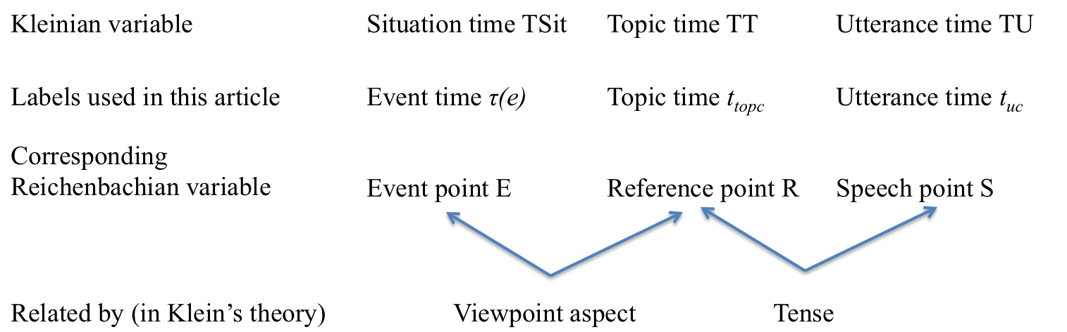
The neo-Reichenbachian authors break Reichenbach’s ternary arrays down into two binary relations, treating the relation between Reichenbach’s ‘speech point’ S (the utterance time) and his ‘reference point’ R as an absolute/deictic tense relation and that between R and the ‘event point’ E (the runtime of the eventuality under description) as a relative/anaphoric tense relation. So relative tense plays a similar role in the neo-Reichenbachian proposals to that played by (viewpoint) aspect in Klein’s theory, partly motivating Klein’s Conjecture that relative tense and aspect are in fact the same thing, or more precisely, that a theory of temporal semantics can account for both in the same way, in terms of ordering relations between topic time and ‘situation time’, the runtime of the described eventuality. But reference and topic times – even though they play similar roles in the two (types of) theories – are quite distinct beasts in terms of their definitions. Reference times are time intervals that are anaphorically tracked across clause boundaries. In contrast, topic times can be understood as evaluation times for speech acts. For assertions, the topic time is the time for which the speaker claims the asserted proposition to be true. For polar questions, it is a time of which the speaker asks whether the proposition is true during it. For commands, it is the time such that the speaker requests/instructs/orders the addressee to make the proposition true during it. And so on. Kratzer 2011 links Klein’s notion of ‘topic time’ to Austin’s (1950) proposal that natural language utterances are about particular situations. These ‘topic situations’ are not to be confused with an eventuality of which the utterance may contain a lexical descriptor, such as a verb. In the examples in (3), the described event is always one of Sally writing a letter to Floyd, but the topic situation contains this event in (3a), is itself contained in it in (3b), and precedes it in (3c) (at least most likely according to a plan the speaker implicitly attributes to Sally):
Figure 1. Some building blocks of Klein's (1994) approach to tense and aspect

(3) a. Sally wrote a letter to Floyd
b. Sally was writing a letter to Floyd
c. Sally was going to write a letter to Floyd

The different aspect forms in (3) motivate Klein’s observation that viewpoint aspect constrains the temporal relation between topic time and event time (or between topic situation and situation under description). Table 1 gives a more comprehensive overview of Klein’s analysis of the semantics of the English tense-aspect categories.

Tense Relation  Aspect Relation | Past  t_{top} < t_{u} | Present  t_{u} ⊂ t_{top} | Future  t_{u} < t_{top}
Perfective  τ(e) ⊆ t_{top} | Simple past  I wrote | Present  I write | Simple future  I will write
Imperfective  t_{top} ⊂ τ(e) | Past progressive  I was writing | Present progressive  I am writing | Future progressive  I will be writing
Perfect  τ(e) < t_{top} | Pluperfect  I had written | Present perfect  I have written | Future perfect  I will have written
Prospective  t_{top} < τ(e) | Past prospective  I was going to write | Present prospective  I am going to write | Future prospective  I will be going to write
Table 1. Klein's (1994) analysis of the English tense-aspect system (key: t_{top} – topic time (projection range); τ(e) - situation time (the runtime of the described eventuality); t_{u} - utterance time)

None of the utterances in (3) involves a reference time in the sense of an anaphorically tracked time interval. However, in the Reichenbachian tradition, a reference time variable is assumed to be a part of the semantics of tense markers, and this variable could receive its value in contexts such as (3) via a mechanism such as existential closure.
To understand the relation between topic times and reference times in connected discourse, considered the mini discourses in (4):

(4) a. Juan entered. Sally wrote a letter to Floyd.
b. Juan entered. Sally was writing a letter to Floyd.
c. Juan entered. Sally was going to write a letter to Floyd.

The topic situations of adjacent sentences in a coherent connected discourse will be interpreted as related to one another. In (4a), the writing event will most likely be interpreted as extending the situation containing the entering event, so the two events will be understood to follow one another in sequence. In the adaptation of the Reichenbachian notion of reference time in the DRT tradition (Hinrichs 1986; Partee 1984; Kamp & Reyle 1993; inter alia), this is described as ‘referential shift’: advancement of the reference time, with the event times of the two perfective clauses being contained in their reference times. In contrast, in (4b) and (4c), the topic situation will be understood to be the same for both clauses. In DRT terms, there is no referential shift. The reference time of the second clause is the event time of the first. The progressive in (4b) locates this reference time inside the writing event, while the prospective in (4c) places it before the writing event.
At the most basic level, it could be said that Klein’s framework parts company with the neo-Reichbachian approaches by reinterpreting reference times as topic times. And it would not be an exaggeration to attribute much of the success of the framework to the explanatory power of this reinterpretation. Topic times have a well-motivated role in the semantics of many natural language utterances in which reference times play no such role and their contribution can only be stipulated. The discussion of the decontextualized examples in (3) has already illustrated this. Another case in point is the phenomenon exemplified in (5):

(5) a. What did you notice when you looked into the room?
b. There was a book on the table. It was in Russian. (Klein 1994: 4)
c. There was a book on the table. #It is in Russian.

Suppose in the context of witness testimony, the witness is asked (5a). Why would (5c) be incoherent even though the book in question has clearly not in any meaningful way stopped being in Russian? Because the question sets the topic time for the response, and that topic time happens to be in the past of utterance time, requiring past tense. The tense shift in (5c) induces incoherence because it can only be understood as indicating a change in the topic situation. If utterances are about, and interpreted with respect to, topic situations, the incoherence in (5c) becomes explainable in analogy to the effect of an abrupt change in discourse topic. Similarly, at a much larger scale, the notion of ‘topic time’ makes predictions for descriptions of the temporal semantics of utterances in tenseless languages such as Mandarin (Klein, Li, & Hendriks 2000) and Yucatec Maya (Bohnemeyer 2002, 2009) that are empirically borne out: if natural language utterances are indeed about topic situations, it follows that topic times should play a role in the interpretation of tenseless utterances as much as they do in that of tensed ones – and they do. In contrast, there is no obvious reason why the semantics of tenseless utterances should involve a reference time variable.
Klein’s theory has also been applied with considerable success to the semantics of aspect systems in languages such as Mandarin and Yucatec (see the references above) and Russian (Klein 1995) in a way Reichenbachian approaches have not. To get a flavor for the reasons behind this success, consider the contrast between (3a) and (3b) above. Why is it that (3a) entails completion of the letter whereas (3b) does not? The answer is intuitively that any proposition the speaker wishes to assert or question, etc., must concern the topic situation. And the topic situation includes the completion of the letter in (3a), but not in (3b) (cf. also Bohnemeyer & Swift 2004; Bohnemeyer 2012). In contrast, while it is possible to describe the contrast between the English simple past and past progressive in terms of the relation between event time and reference time, this in no way explains the distinct entailment patterns. Why would inclusion of the reference time in the event time mean that the completion of the event is not entailed? There is no obvious nexus between the reference time of an utterance and its entailments unless the reference time is defined as a topic time.
Finally, and for similar reasons, Klein’s approach has also made important contributions to the theoretical understanding of finiteness and its interaction with temporal interpretation (Klein 1998, 2006, 2009).
It could be said that Klein moves to reinterpret reference times as topic times, and this in turn leads him to reinterpret relative tenses as aspects. By simply replacing the notion of ‘reference time’ with that of ‘topic time’ and the notion of ‘relative tense’ with that of ‘viewpoint aspect’, Klein follows Occam’s Razor: he proposes the simplest theory that can account for the data he set out to account for. However, Klein’s Conjecture is an empirically testable hypothesis, and it is my goal in the present article to present additional data that discourages it and thereby calls for a more powerful theory, one that includes both topic times and reference times in its conceptual toolkit and recognizes viewpoints aspects and relative tenses as distinct functional categories.
Let me conclude this sketch of some of the basic elements of Klein’s theory by briefly outlining a possible formalization (cf. also Bohnemeyer & Swift 2004 and Bohnemeyer 2012). Assume a model that includes domains D_{e} of events (i.e., individuals of the continuant variety), D_{i} of individuals (of the perdurant variety), and D_{I} of time intervals, with a mereological partial-order relation « defined over D_{e} and the usual total orders < (precedence) and ⊂ (inclusion) and the corresponding partial orders ≤ and ⊆ defined over D_{I}. The temporal trace function τ: D_{e} D_{I} maps eventualities to their run times. Natural language eventuality descriptions denote properties of events. Figure 2 diagrams the semantic composition of (3c) in a simplified manner, treating the entire lexical content of the clause as an event predicate in abstraction from linear order and thus circumventing the type raising of the subject Sally. The values of the topic time variable t_{topc} and the utterance time variable t_{uc} are a function of context c. All expressions whose semantics involves the topic time variable are marked for this context dependence by a superscript c. Tense as the outermost operator considered in Figure 2 is represented as triggering existential closure of the event description. The analysis of all other tense-aspect combinations follows by replacing the constraints on the topic time projection range supplied by the aspectual component (the lower left node in Figure 2) and/or the tense component (the higher left node) with the appropriate relations listed in Table 1.

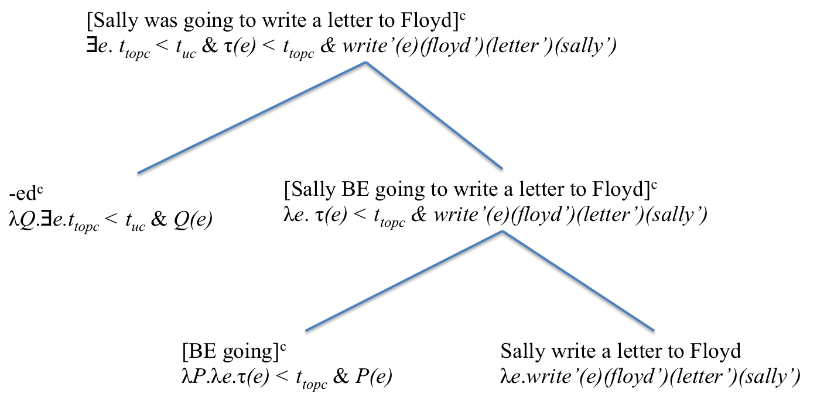
Figure 2. Simplified semantic composition for (3c) based on Klein 1994

3. Klein’s Conjecture
Let me begin with a more explicit statement of Klein’s Conjecture. The formulation in (6) is of course mine, not Klein’s:

(6) Klein’s Conjecture: The functional categories traditionally classified as ‘viewpoint aspects’ and ‘relative tenses’, respectively, both constrain the range of possible topic times of the utterance in terms of a fixed relation vis-à-vis the runtime of the described eventuality. Apart from meaning components that are neither viewpoint aspects nor relative tenses, their meanings can be exhaustively characterized in terms of relations between topic times and event times.

The motivation behind (6) was outlined in the previous section:

- Traditionally, tenses have been assumed to relate event times either to utterance times – in the case of absolute (i.e., deictic) tenses – or alternatively, in the case of relative (i.e., anaphoric) tenses, to reference times.
- Klein’s theory reinterprets the reference times of the Reichenbachian tradition (and Reichenbach’s antecedents dating back to antiquity) as topic times.
- Replacing reference times with topic times enables the theory to add a powerful aspect module, which treats viewpoint aspects in terms of relations between event and topic times.
- Combined with the reanalysis of reference times as topic times, the traditional analysis of relative tenses as relating event times to reference times suggests that the semantics of relative tenses, like that of viewpoint aspects, can be characterized in terms of relations between event times and topic times. In the simplest possible theory that is in line with the data, the aspect component should be able to capture the semantics of both types of functional categories. The reanalysis of reference times as topic times thus triggers a reanalysis of relative tenses as a special kind of viewpoint aspects.

Under the above interpretation, Klein’s Conjecture entails the correspondences in Table 2:

Traditional relative tense category | Corresponding aspectual category  In Klein (1992, 1994)
anterior (relative past) E < R | Perfect τ(e) < t_{top}
posterior (relative future) R < E | Prospective t_{top} < τ(e)
simultaneous (relative present)  E and R overlap  | Perfective τ(e) ⊆ t_{top}  or Imperfective t_{top} ⊂ τ(e)
Table 2. Relative tense categories and corresponding viewpoint aspect categories under the assumption that reference time R corresponds to topic time t_{top}

I argue in the following that (6) is false and that true relative tenses – in those languages that have them – in fact do not constrain the relation between topic time and event time, but rather that between topic time and some reference time tracked in discourse. Moreover, viewpoint aspects may have additional semantic properties that further distinguish them from relative tenses. But to be able to account for these additional properties, the theory must be expanded to include relations not just between topic time and the event time but also between topic time and the runtimes of the pre- and post-states surrounding the described eventuality in the causal chain.

4. The English present perfect revisited
In sections 5-6, I present crosslinguistic evidence for the existence of pure perfect (and prospective) aspects and pure anterior (and posterior) tenses. The complex tenses of English, however, are compatible with both aspectual and relative-tense interpretations. Traditionally, this was considered a case of polysemy. Table 3 illustrates with the aspectual vs. anaphoric (relative-tense) interpretations of the perfect tenses according to Comrie 1976 and Jespersen 1924:

Nondeictic component  Deictic component | Aspect  (Result focus) | Anterior Tense  (Event focus)
Present | Present perfect | N/A
Past | Perfect in the past | Past in the past
Future | Perfect in the future | Past in the future
Table 3. Traditional (Pre-Reichenbachian) analysis of the English perfect tenses

Jespersen’s terms are ‘retrospective past’ vs. ‘ante-preterit’ for Comrie’s ‘perfect in the past’ vs. ‘past in the past’ and ‘retrospective future’ vs. ‘ante-future’ for Comrie’s ‘perfect in the future’ vs. ‘past in the future’. The present perfect, then, is a ‘retrospective present’ is Jespersen’s terminology. Although Jespersen does not include the ‘retrospective’ tenses under his notional ‘aspect’ categories, he agrees with Comrie in claiming that their core meaning is “the element of result” (1924: 269).
Comrie’s (1976) illustration of the contrast between the aspectual perfect-in-the-past and the anaphoric past-in-the-past interpretations of the pluperfect was cited in (1)-(2) in the introduction, repeated here for convenience:

(7) Bill had arrived at six o’clock. I arrived at six sharp, and he was already half done with his meal, so he must have gotten there a lot earlier.
(8) Bill had arrived at six o’clock and had left again at seven. The inspector did not get there until eight. (Comrie 1976: 56)

Klein’s Conjecture entails that these two interpretations are generated neither by a contrast between two constructions that license the same surface string (syntactic ambiguity) nor by one between two distinct meanings associated with a single construction by the grammar of English (polysemy), but rather are the result of a single construction with a single general (i.e., underspecified) meaning. Indeed, Klein 1992 argues that the semantic difference between (7) and (8) is simply due to the interpretation of the time adverbial at six o’clock, which is understood to specify the topic time of the first sentence in (7), but the event time in (8). This raises the question why only topic time adverbials, not event time adverbials, are compatible with the present perfect:

(9) Bill has arrived now/*at six o’clock.

Klein (1992) refers to this asymmetry as the present perfect puzzle. He proposes the following explanation: by requiring topic time to include utterance time (see Table 1 above), the present tense narrowly specifies topic time in a way past and future tenses do not: present tense marking renders topic time ‘positionally definite’ or ‘p-definite’. But it is pragmatically infelicitous for both topic time and event time to be specified for p-definitess in the same utterance:

(10) #At 7pm, Bill had arrived at six o’clock.

One might attribute the infelicitousness of (10) to the event time specification rendering the topic time specification vacuous, somewhat similar to the vacuousness of the locative phrase in (11):

(11) #At the hip, Sally is 6ft tall/weighs 120lb.

Since Sally’s height and weight are properties of Sally as a whole, it makes no sense to assert them with respect to particular parts. Similarly, the location in time of the arrival event in (10) is a property of that event that does not change depending on the topic time.
This analysis is ingenious and compelling. I nevertheless believe that it is not the full story. Standard polysemy tests do seem to suggest that the English pluperfect and future perfect are polysemous between aspectual (perfect in the past/future) and relative-tense (past in the past/future) interpretations. Consider (12)-(13).

(12) Bill had not (already) arrived at six o’clock. We both arrived at six sharp; he did not get there earlier.
(13) Bill had not arrived at six o’clock. He got there at 5:40 already.

Example (12) is an attempt at denying the pluperfect Bill had arrived at six o’clock under the perfect-in-the-past interpretation (Bill was already there at six) while asserting the past-in-the-past interpretation (Bill arrived at six, prior to some subsequent reference point). This seems problematic because it relies on the logical but non-intuitive assumption that Bill would have had to arrive at least an infinitesimal moment prior to six o’clock in order for him to be at six in the result state of arriving. Contradiction can be avoided by inserting already in the pluperfect clause. The question-answer format in (14) serves the same purpose:

(14) Q: When you got there at six o’clock, had Bill (already) arrived?
A: No, he and I arrived at precisely the same time.

Example (13), however, is relatively inconspicuous. It shows that it is possible without contradiction to deny the application of the past-in-the-past interpretation while leaving the perfect-in-the-past sense unchallenged. Discrete deniability is a standard diagnostic of polysemy. Expressions that are associated with multiple senses in the mental lexicon or in the grammar of the language are predicted to be deniable under one sense while simultaneous assertion of the other in the same situation, with respect to the same context and the same set of possible worlds, does not result in contradiction. This is illustrated by (15-18):

(15) That’s not a cow; that’s a bull.
(16) #That’s not a horse; that’s a mare.
(17) Floyd isn’t a doctor; he has a PhD in linguistics.
(18) #Sally isn’t a monarch; she’s a queen.

The tests suggest that cow is polysemous between the senses ‘bovine’ and ‘female bovine’ and that doctor is polysemous between ‘physician’ and ‘person with a doctorate’, while horse and monarch underspecify the sex of the referent. Although this diagnostic is most commonly applied in lexical semantics (see the discussion in Cruse 1986: 58-74), I see no reason to doubt its validity for the semantics of function words and inflections unless one assumes that there is a fundamental difference between polysemy in the mental lexicon and in the grammar – a move that at present would seem without motivation.
The following examples apply the discrete deniability test to the future perfect, using the question-answer format of (14):

(19) Q: When you will get there at six, will Bill have arrived?
A: No, Bill will get there at precisely the same time I will.
(20) Q: When I will meet the two of you tomorrow, will Bill have arrived at six?
A: No, he will get there at 5:40 already.

Deniability of the perfect-in-the-future sense without the past-in-the-future sense being affected is shown in (19); (20) establishes that the past-in-the-future sense can be denied while leaving the perfect-in-the-future sense intact.
The evidence presented above suggests that the pluperfect and future perfect are not simply underspecified for the aspectual (perfect-in-the-past/future) and anaphoric-tense (past-in-the-past/future) interpretations, but rather have these as discrete polysemous senses. How then can it be explained that the present perfect lacks the anterior tense meaning? The answer, I suspect, has to do with the fact that the pluperfect and future perfect, in their relative tense uses, are not pure anaphoric tenses – unlike the Japanese, Korean, and Kituba anaphoric tenses described in section 6 – but rather deictic/anaphoric “hybrids.” The deictic tense component expressed by the auxiliary serves to confine topic time to the past/future of utterance time, while the anterior tense component expressed by the participle marks anteriority of topic time with respect to some reference time (see section 7). Moreover, the event times expressed by the adverbials in (8), (13), and (20) actually fall into the topic time projection ranges delimited by the anterior tense component on this analysis. That is, on the anterior past/future reading, the pluperfect and future perfect are aspectually perfective. Independent evidence suggesting perfectivity comes from the fact that these forms support referential shift (cf. Kamp & Reyle 1993: 593-601). For example, the events described by the non-initial pluperfect forms in (21) and the future perfect forms in (22) are understood each as being realized within a topic time that follows that of the preceding verb form:

(21) Bill had arrived, unpacked, taken a shower, and called a taxi.
(22) Bill will have arrived, unpacked, taken a shower, and called a taxi.

Moreover, the fact that the anterior tense reading is compatible with event time adverbials likewise suggests perfectivity. Outside future time reference, event time specifications are by and large restricted to perfective descriptions, since it is perfective descriptions that place completion of the event inside topic time and thereby inside the scope of assertion, question, etc.
Extending the combination of anterior tense and perfective aspect to the present perfect would yield a topic time projection range that must include utterance time while simultaneously preceding a reference time, which thus would have to lie in the future. This would render the anterior tense component vacuous, as a present topic time necessarily precedes any possible future reference time (and any other future time, for that matter). And it would still not license past event time specifications such as the one attempted in (10), since present topic times cannot include past event times.

5. Pure perfect aspects
By “pure” perfect aspects, I am referring to markers that do not conflate any tense component, be it deictic or anaphoric. Exhibit A, and my main source of evidence and focus of attention in this section, comes from my own field research on Yucatec, the Mayan language spoken widely across the Yucatan peninsula in Mexico and Belize. As argued extensively in Bohnemeyer (1998, 2002, 2009), Yucatec is a tenseless language. Thus, a clause with the perfect aspect marker ts’o’k, customarily labeled ‘terminative’ by Yucatecanists due to its relation to the homophonous phase verb meaning ‘end’, is freely compatible with topic times in the present, past, and future of utterance time, as illustrated in (23):

(23) Ts’o’k in=mèet-ik le=nah=o’.
TERM A1SG=do:APP-INC(B3SG) DET=house=D2
‘I (will) have/had built the house.’

The following example illustrates the use of ts’o’k with a topic time determined by a preceding clause:

(24) Káa=h-tàal-ech way h-ts’o’k ka’-p’éel ha’b=e’,
CON=PRV-come-B2SG here PRV-end(B3SG) two-CL.IN year=TOP
ts’o’k in=mèet-ik le=nah=o’
TERM A1SG=do:APP-INC(B3SG) DET=house=D2
‘(When) you came here two years ago, I had built the house.’

The event time of the ts’o’k clause – the time of building the house – is understood as preceding the event time of the first clause, the time of the addressee’s earlier visit. On the aspectual analysis, this follows from ts’o’k placing the topic time projection range inside a time at which a result state (the precise nature of which may be pragmatically determined) of the building event obtains. On an alternative anterior tense analysis, ts’o’k expresses anteriority with respect to a reference time, which in conversation may be interpreted to be the utterance time, as conversations are discourses that are referentially grounded in the speech situation. However, under an anterior tense analysis, it should be possible for ts’o’k clauses to accept event time adverbials – contrary to fact. Event descriptions with event time adverbials referring to the deictic or anaphoric past must be marked for perfective aspect, as illustrated in (25a). Attempts at using ts’o’k instead are rejected by speakers (25b).

(25) a. T–aw=il–ah in=suku’n ho’lheak,
PRV–A2=see–CMP(B3SG) A1SG=elder.brother yesterday he’bix t–a=tukul–ah=e’?
like PRV–A2=think–CMP(B3SG)=D3
‘Did you meet my brother yesterday, as you had planned?’

b. #Ts’o’k aw =il–ik in=suku’n ho’lheak?
TERM A2=see–CMP(B3SG) A1SG=elder.brother yesterday
(intended: ‘Have you met my brother yesterday?’)

The only possible interpretation of the adverbials ho’lheak in (25b) is as a topic time adverbial, which pragmatically makes little sense (‘Were you yesterday in the state of having met my brother?’). Moreover, topic time adverbials are strongly preferred to be left-dislocated.
Similarly, ts’o’k is unacceptable in time-positional content questions and relative clauses that modify heads understood to refer to their event times. For instance, the dependent question in (26a) is illformed. To repair it, ts’o’k must be replaced by a verbal core inflected for subjunctive status, as in (26b):

(26) a. Mix inw=ohel *ba’x òora ts’o’k u=hàan-al.
EMPH.NEG A1=know(B3SG) what hour TERM A3=eat-INC
(intended: ‘I have no idea at what time he had eaten.’)

b. Mix inw=ohel ba’x òora hàan-ak=i.
EMPH.NEG A1=know(B3SG) what hour eat-SUBJ(B3SG)=D4
‘I have no idea at what time he had eaten.’

Ts’o’k clauses do not in fact entail any information about their event times other than that they precede their topic times. This is shown by the lengthy textlet in (27), in which a speaker asserts a ts’o’k clause while simultaneously stating that he does not know when the described event happened:

(27) Pedro=e’ h-hàan las sèeys.
Pedro=TOP PRV-eat(B3SG) six.o’clock
‘Pedro, he ate at six.’

Chéen dyèes minùuto-s t-u =bis-ah.
only ten minute-PL PRV-A3=go:CAUS-CMP(B3SG)
‘It took him just ten minutes.’

Las syèete káa=h máan Pablo,
seven.o’clock CON=PRV pass(B3SG) Pablo
‘(At) seven, Pablo came by,’

káa=t-uy=ohel-t-ah ts’-u=hàan-al Pedro.
CON=PRV-A3=know-APP-CMP(B3SG) TERM-A3=eat-INC Pedro.
‘(and then) he learned that Pedro (already) had eaten.’

Chen ba’l=e’, ma’ t-uy=ohel-t-ah
only thing=TOP NEG PRV-A3=know-APP-CMP(B3SG)
‘However, he did not come to know’

ba’x òora káa=h-hàan Pedro=i’.
what hour CON=PRV-eat(B3SG) Pedro=D4
‘at what time Pedro had eaten.’
Las òocho=e’ t-uy=a’l-ah Pablo ti’ Juan=e’:
eight.o’clock=TOP PRV-A3=say-CMP(B3SG) Pablo PREP Juan=TOP
‘At eight, Pablo said to Juan:’

“Káa=h-máan-en t-uy=iknal Pedro las syèete=e’,
CON=PRV-pass-B1SG PREP-A3=at Pedro seven.o’clock=TOP
‘“(When) I went by Pedro’s at seven,’

ts’o’k u=hàan-al leti’; chen ba’l=e’,
TERM A3=eat-INC it only thing=TOP
‘he had (already) eaten; only,’

mix inw=ohel ba’x òora hàan-ak=i”.
EMPH.NEG A1=know(B3SG) what hour eat-SUBJ(B3SG)=D4
‘I have no idea at what time he had eaten.”’

Thus, ts’o’k clauses are neither compatible with event time adverbials nor even pragmatically understood as providing information about the time of the described eventuality. An analysis that underspecifies the distinction between perfect aspect and anterior tense cannot seem to explain this behavior. The analysis I wish to propose accounts for it by placing the topic time projection range inside the runtime of a state caused by the described eventuality. On this analysis, the semantic predicate evaluated (asserted, questioned, etc.) with respect to topic time is not an event description, but a (resultant) state description. My assumption is that only this state description is accessible to temporal modification. Figure 3 illustrates this analysis for (23):

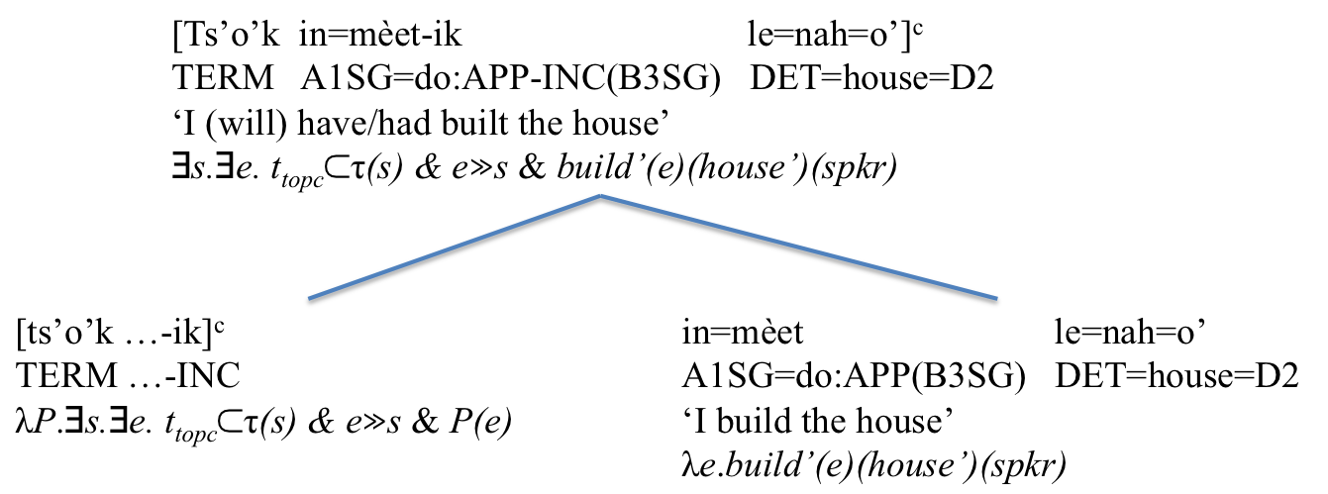
Figure 3. Simplified semantic composition for (23)
For the sake of convenience, Figure 3 treats ts’o’k and the incompletive ‘status’ suffix -ik obligatorily triggered by it as entering the semantic composition together as an unanalyzed package. The analysis expands the model theory sketched in section 2 by adding a subdomain D_{s} ⊂ D_{e}, the domain of states, and the causal relation », which defines a strict partial order over D_{e}.
One more piece of independent evidence in support of the analysis in Figure 3 is the fact that ts’o’k, just like the English present perfect, is anomalous or infelicitous (depending on whether the effect is assumed to be semantic or pragmatic; it is not entirely clear which one it is) when an individual involved in the result state no longer exists at topic time. Thus, as (28b) shows, speakers reject ts’o’k as a substitution for the perfective in (28a), because the speaker states that his father has passed away:

(28) a. T-a=k’ahóol-t-ah in=tàatah,
PRV-A2=acquaintance-APP-CMP(B3SG) A1SG=father
le=máax h-kim te=ha’b h-máan=o’?
DET=who PRV-die(B3SG) PREP:DET=year PRV-pass(B3SG)=D2
- Míin chen hun-téen-ili’ t-inw=il-ah.
DUB only one-time-UP PRV-A1SG=see-CMP(B3SG)
‘Did you get to know my father who died last year? - I think I only met him once.’

b. #Ts’o’k a=k’ahóol-t-ik in=tàatah,
TERM A2=acquaintance-APP-INC(B3SG) A1SG=father
le=máax h-kim te=ha’b h-máan=o’?
DET=who PRV-die(B3SG) PREP:DET=year PRV-pass(B3SG)=D2
- #Míin chen hun-téen-ili’ ts’o’k inw=il-ik.
DUB only one-time-UP TERM A1SG=see-INC(B3SG)

This is entirely parallel to the famous (29):

(29) a. (Uttered in 1971) #Einstein has visited Princeton.
b. (Uttered in 1971) ?Princeton has been visited by Einstein.

The existence of pure perfect aspects does not seem to be restricted to Yucatec. The properties of ts’o’k discussed above are shared by the Kalaallisut (West-Greenlandic) marker –sima-, according to Fortescue’s (1984) description. Kalaallisut is one of three dialects of the Eskimo-Aleut language of Greenland. Like Yucatec, it is a tenseless language (Bittner 2005, 2008). (30) shows –sima- with a past topic determined by a preceding clause, (31) with a future one determined by an adverbial:

(30) Angirla-rama allakkat atuar-sima-vai.
come.home-1SG.CAUSE letter(PL) read-PERF-3SG.3PL.IND
‘When I came home he had read the letters.’ (Fortescue 1984: 274)
(31) Aqagu siku-mi sivisuu-mik aallar-sima-ssa-(p)u-nga.
tomorrow ice-LOC long-MOD leave-PERF-EXP-DEC-1SG
‘I will (lit. expect/am expected to) be gone out on the ice a long time tomorrow.’ (Bittner ms. 15)

Like ts’o’k, -sima- is incompatible with event time specifications. Fortescue notes that it can occur in the context of (32), but not in that of (33):

(32) Nuum-miis-sima-vunga.
Nuuk-be.in-PERF-1SG.IND
‘I have been to Nuuk.’ (Fortescue 1984: 272)
(33) Juuli-p aappa-ani Nuum-miip-∅-punga.
July-ERG second-LOC Nuuk-be.in-ASP-1.SG.IND
‘I was in Nuuk on the second of July.’ (Fortescue 1984: 273)

Having seen evidence of pure perfect aspects, the question now arises whether the second interpretation of the complex perfect forms of English – the relative tense interpretation – likewise occurs in isolation, i.e., in expressions that do not have perfect aspect uses. This question is the topic of the next section.

6. Pure anterior tenses
A pure anterior tense constrains topic time vis-à-vis some reference point given in the discourse context rather than vis-à-vis utterance time. That the anterior relation holds between the reference time and topic time, not the time of the described eventuality, is apparent from the fact that anaphoric tenses, like deictic tenses, may be aspectually neutral and syntagmatically combine with overt aspect markers, but may also implicate or express a viewpoint aspect operator in addition to its tense meaning. A case in point is Japanese –ta on Ogihara’s (1996, 1999) account. Example (34) shows -ta in an embedded clause expressing anteriority relative to the matrix clause, which is understood to describe a future eventuality:

(34) Taroo-wa [terebi-o mi-ta ato-de] benkyoo-suru.
Taro-TOP TV-ACC watch-ANT after-LOC study-PRES
‘Taro will study after watching TV.’ (Ogihara 1999: 329)

In the absence of appropriate contextual specifications, the default reference time for matrix clauses is utterance time, as illustrated in (35):

(35) Taroo-wa kinoo hon-o yon-da.
Taro-TOP yesterday book-ACC read-ANT
1) ‘Taro (had) read the book yesterday.’
2) ‘*As of yesterday, Taro had read the book.’ (Ogihara 1999: 330)

When not accompanied by an aspect marker, -ta clauses are interpreted perfectively, i.e., to the effect of inclusion of the runtime of the described eventuality in the topic time of the –ta form. Thus, the time adverbial in (35) is understood to specify the event time, not the topic time or reference time. As Ogihara points out, a perfect interpretation under which the time adverbial would specify a topic time following the time of the reading event is unavailable in (35). However, to obtain this interpretation, -ta can be combined with the –te iru construction, as illustrated in (36):

(36) Taro-wa kinoo-no jiten-de sudeni
Taro-TOP yesterday-GEN timepoint-LOC already
sono hon-o yon-de ita.
that book-ACC read-TE be:ANT
1) ‘As of yesterday, Taro had already read the book.’
2) ‘As of yesterday, Taro was already reading the book.’ (Sotaro Kita, p. c.; Mitsuaki Shimojo, p. c.)

The –te iru form has both perfect and imperfective/progressive interpretations. In either case, it maps an eventuality description into a related state (Nishiyama & Koenig 2010). Figure 4 diagrams an analysis of (35) in line with the ideas developed above. The adverbial kinoo ‘yesterday’ is interpreted as an event time adverbial ignoring linear order. The function antday: D_{I} D_{I} maps time intervals into the calendar day preceding the day containing them. The reference time variable t_{rc}, like the topic time variable t_{topc}, is interpreted indexically, i.e., its value is a function of the context.
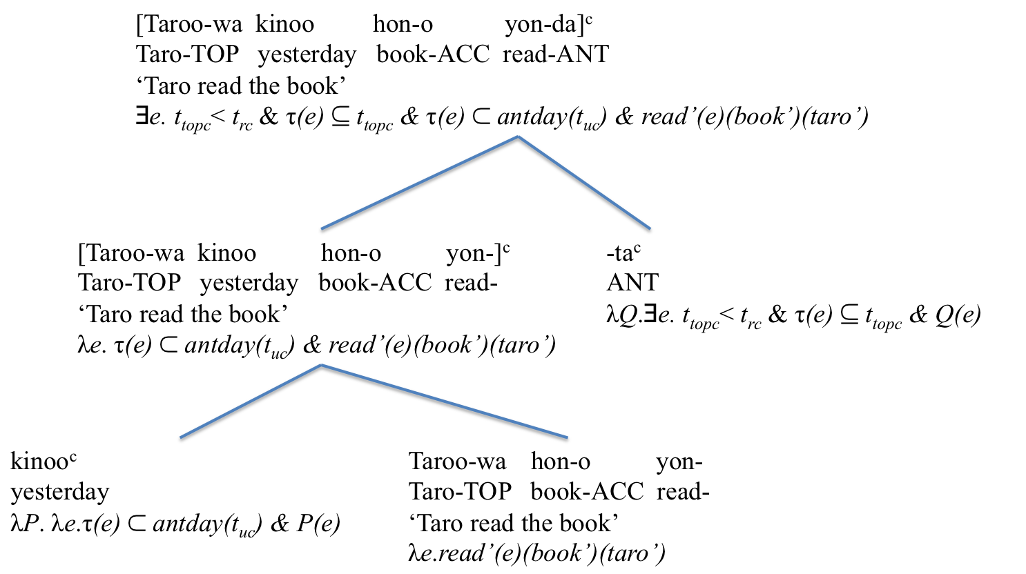
Figure 4. Simplified semantic composition for (35)

Figure 4 describes –ta as inherently perfective. However, the compatibility of –ta with the –te iru form (cf. (36)) suggests that perfectivity may be a stereotype implicature. Future research will have to clarify this.
A set of properties strikingly similar to that of –ta has been attested for the suffix
–á(k)a in the Bantu language Kituba, spoken in the Democratic Republic of Congo.
As (37) illustrates, – á(k)a encodes anteriority relative to some reference time, irrespective of whether the latter is in the past, present, or future of the utterance time.

(37) a. Ntángu ya María kwis-á(k)a, múna béto méne di-áka.
time CMP María come-ANT then we PERF eat-ANT
‘When María came, we had already eaten [a long time / quite some time ago].’
b. Ntángu ya María ata kwis, múna béto méne di-áka.
time CMP María POST come then we PERF eat-ANT
‘When María comes, we will have already eaten [a long time / quite some time ago].’ (Mufwene 1990: 99-100)

The examples in (37) involve topic times that do not include the runtime of the described eventualities, but instead follow them, indicating perfect aspect. However, it turns out that this is due to the presence of the perfect auxiliary mé(ne), which expresses perfect independently of –á(k)a. Mé(ne) clauses admit topic time specifications, but not event time specifications, in the absence of –á(k)a (cf. (38)), while –á(k)a clauses without mé(ne) allow for event time specifications, but require the event time to be included in the topic time, i.e., are interpreted perfectively (cf. (39)). I tentatively conclude that -á(k)a, like Japanese –ta, may not express aspect, but rather implicate perfectivity when not accompanied by an overt aspect marker.

(38) Béto mé(ne) dia / búbu yáyi / mazóno.
we PERF eat / day this / yesterday
1) *‘We ate today/yesterday’
2) ‘As for today/yesterday, we are/were in the state of having eaten.’
(39) Béto di-á(k)a / búbu yáyi / mazóno.
we eat-ANT / day this / yesterday
1) ‘We ate today/yesterday’
2) *‘As for today/yesterday, we are/were in the state of having eaten.’ (Mufwene 1990: 101)

It has been established that both perfect aspects lacking anterior tense interpretations and anterior tenses lacking perfect aspect interpretations exist in the languages of the world. We now revisit the deictic-anaphoric hybrid tenses of English. As it turns out, these likewise occur in other, unrelated languages. And where they do, they may not have perfect aspect interpretations, unlike their English counterparts.

7. Deictic-anaphoric hybrid tenses
Deictic-anaphoric hybrids are tenses that combine an anaphoric tense relation between topic time and reference time with a deictic relation between reference time and utterance time. On the analysis defended in this article, the English future perfect and pluperfect on their non-aspectual interpretations are cases in point. At least for these English expressions, a conceivable alternative analysis under which both the deictic and the anaphoric meaning component involve topic time as a relatum, one constraining it with respect to utterance time and the other with respect to reference time, conflicts with examples such as (40):

(40) When you arrive at his home tomorrow, Bill will have left five days ago (so you may want to check whether the plants need water).

The future perfect clause in (40) describes an event presented as having occurred four days prior to utterance time, while the reference time, introduced by the temporal clause, lies in the future of utterance time. Were the finite = deictic component of the hybrid tense to restrict topic time rather than reference time with regard to utterance time, (40) ought to involve the pluperfect rather than the future perfect. Yet substitution of the pluperfect for the future perfect renders (40) anomalous:

(40’) #When you arrive at his home tomorrow, Bill had left five days ago.

A second example of a deictic-anaphoric hybrid tense in an unrelated language is the Korean pluperfect marker –essess. This expression differs from Japanese –ta and Kituba –á(k)a in that it, like the English pluperfect on its anterior tense interpretation, combines the expression of a relation between topic time and an anaphorically tracked reference time with that of a relation between this reference time and utterance time. At the same time, –essess patterns with –ta and –á(k)a, but not with the English pluperfect, in that it does not have a perfect interpretation. –Essess might be considered a particularly clear case of a deictic-anaphoric “hybrid” tense since it is etymologically constituted by reduplication of the simple past marker –ess. Except for the fact that one of the two tokens of –ess has anaphoric rather than deictic reference, the combination can be analyzed compositionally, one token expressing anteriority of reference time vis-à-vis utterance time and one anteriority of topic time vis-à-vis reference time. The following pair of examples contrasts the two markers:

(41) a. Mina-ka cip-ey kaass-ta.
Mina-NOM home-LOC go:PAST-DEC
‘Mina went home.’
b. Mina-ka cip-ey kassess-ta.
Mina-NOM home-LOC go:PLUPERF-DEC
‘Mina had gone home (but has come back now).’ (Lee 2010: 770)

-Essess does not express perfect aspect. It is anomalous in (42) under the interpretation of the subordinate clause as a topic time rather than an event time specification (in other words, on the interpretation that the train left before Suni’s arrival):

(42) #Suni-ka yek-ey tochakhay-(e)ss-ul ttay
Suni-NOM station-LOC arrive-PAST-when
kicha-nun ttenassess-ta.
train-TOP leave:PLUPERF-DEC
Intended: ‘When Suni arrived at the station, the train had (already) left.’ (Lee 2010: 770)

The expression of perfect aspect in Korean is the construction –e iss illustrated in (43):

(43) John-un ahop-si-ey konghang-ey tochakhayss-ta.
John-TOP nine-o’clock-LOC airport-LOC arrive:PAST-DEC
‘John arrived at the airport at nine.’
Mary-nun pelsse konghang-ey tochakhayiss-ess-ta.
Mary-TOP already airport-LOC arrive:PERF-PAST-DEC
‘Mary had already arrived at the airport.’
John-un Mary-lul po-ko uws-ess-ta.
John-TOP Mary-ACC see-and smile-PAST-DEC
‘John smiled at Mary.’

Figure 5 diagrams an analysis of (41b). Like the analysis of Japanese –ta provided in Figure 4, the analysis in Figure 5 assumes that –essess is inherently perfective due to its compatibility with event time specifications. However, just as in the case of –ta, the perfective interpretation might in fact be an implicature – this remains to be investigated. Figure 5 also ignores the contribution of the declarative mood. Assuming that it is an unmarked mood for assertions, it should not affect the truth conditions of the formula the example is translated into.

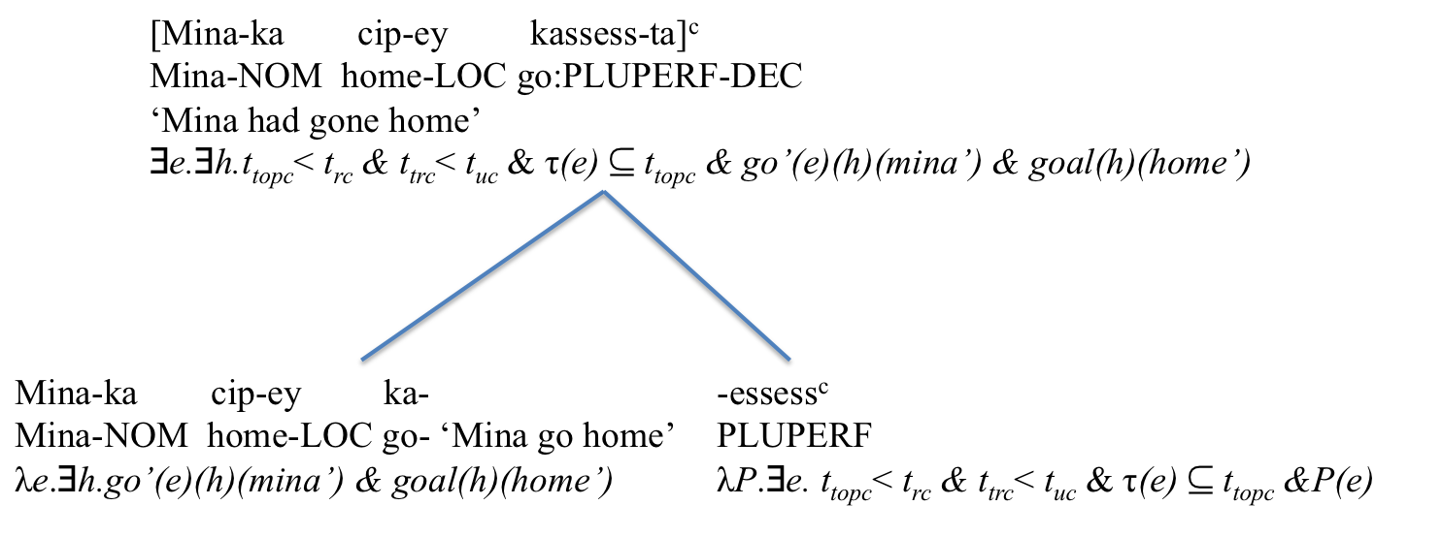
Figure 5. Simplified semantic composition for (41b)

This precludes the presentation of typological evidence. I now turn to the discussion of the implications of this evidence for the theory of temporal semantics.

8. Implications for Klein’s theory
The evidence from ambiguity tests presented in section 4 suggests that the English pluperfect and future perfect are ambiguous between anterior tense (past-in-the-past/future) and perfect aspect (perfect-in-the-past/future) interpretations. The typological evidence presented in sections 5-7 confirms the existence of perfect aspects and anterior tenses with distinct semantic properties in the languages of the world. Based on the analyses developed above, the two readings of (44) can be represented as in Figure 6-7.

(44) Bill had arrived at six o’clock.

The ambiguity as captured by the analysis represented in the two diagrams is located primarily in the participle, which expresses anterior tense in Figure 6, but perfect aspect in Figure 7. However, the meaning of the auxiliary is affected as well, since it is understood to relate utterance time to reference time in Figure 6, but to topic time in Figure 7. Nevertheless, I do not think that it is necessary to treat the auxiliary as polysemous as well. Reference times are just a special case of topic times. As long as it is ensured that the auxiliary picks up the right topic time in a multi-topic-times utterance – the right one being the outermost one, the one tracked in connected discourse – a monosemous tense auxiliary can do the job.

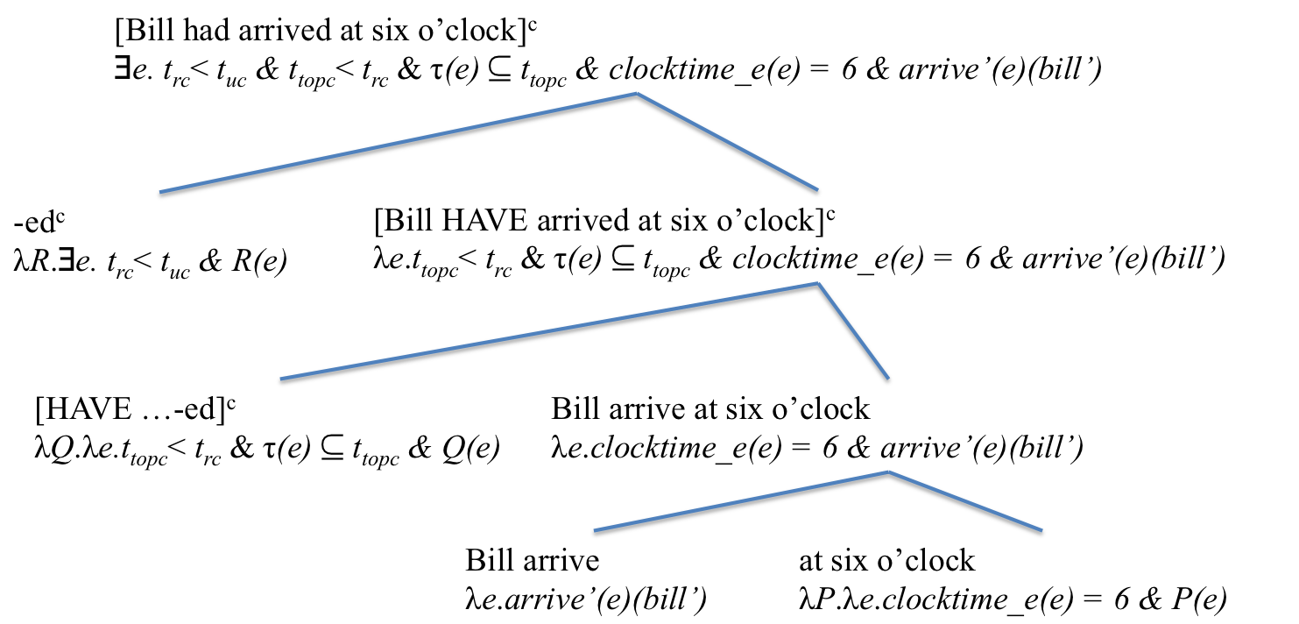
Figure 6. Simplified semantic composition for the past-in-the-past interpretation of (44)
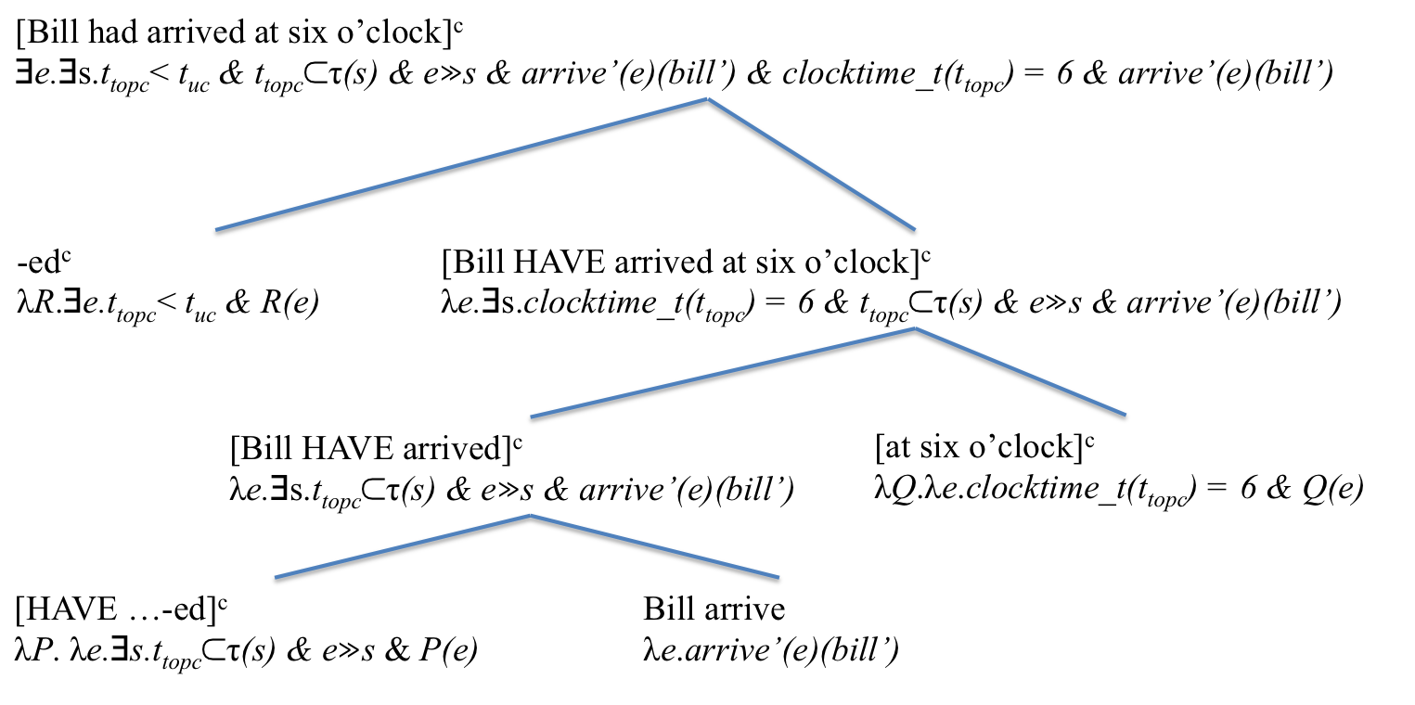
Figure 7. Simplified semantic composition for the perfect-in-the-past interpretation of (44)

The role of the adverbial in the semantic composition differs of course as well across the two examples. The adverbial is interpreted as modifying the event time with the past-in-the-past reading in Figure 6, but as modifying topic time with the perfect-in-the-past reading in Figure 7. The difference is captured by two related functions, clocktime_e: D_{e} Ν×Ν, which maps events into ordered pairs of natural numbers that represent their clock time (up to the minute), and clocktime_t: D_{I} Ν×Ν, which does the same with time intervals. The two adverbials also differ in where they enter the semantic composition: the event time adverbial in Figure 6 modifies the bare lexical event description, whereas the topic time adverbial in Figure 7 modifies the participle projection, which is marked for (perfect) viewpoint aspect.
In order to account for the semantic differences between perfects and anterior tenses (and the corresponding difference between prospective aspects and posterior tenses) and express the distinct analyses developed above, both the viewpoint aspect and the tense component of the theory presented in Klein (1992, 1994, 1995, etc.) must be amended. Let us consider these necessary upgrades in turn.
A key property of perfect aspects such as Yucatec ts’o’k, Kalaallisut –sima-, and the non-finite part of the English present perfect is their incompatibility with event time adverbials. Klein’s ‘time-relational’ analysis of viewpoint aspect in terms of temporal relations between topic time and event time cannot explain this behavior precisely because the behavior is restricted to perfect aspects and Klein’s analysis does not distinguish those from anterior tenses. In section 5, the incompatibility of perfect aspects with event time adverbials was explained with reference to the topic situation, and therefore the scope of assertion/question/etc., overlapping with a suitable result state rather than with the event itself. This analysis instantiates a treatment of viewpoint aspect in terms of temporal relations between topic time and, not merely event time, but the run times of various stages of a causal chain (see above) in which the described event is embedded, as proposed in Bohnemeyer (1998, 2002, 2009). Table 4 illustrates:
Table 4. A mereological theory of viewpoint aspect (Bohnemeyer 1998, 2002, 2009)
Notional aspect marker | Part of the causal chain selected | Semantics | Example
Prospective | Pre-state | λP.∃e.∃s.s » e  & t_{topc} ⊂ τ(s) & P(e) | Sally was going to write a paper on aspect
Ingressive | Initial boundary | λP.∃e.ini(e) ⊆ t_{topc} & P(e) | Sally started writing  a paper on aspect
Progressive/  imperfective | Central part | λP.∃e.t_{topc} ⊂ τ(e) & P(e) | Sally was writing  a paper on aspect
Egressive | Terminal boundary | λP.∃e.fin(e) ⊆ t_{topc} & P(e) | Sally finished writing  a paper on aspect
Perfective | Entire event | λP.∃e.τ(e) ⊆ t_{topc} & P(e) | Sally wrote a paper on aspect
Perfect | Post-state | λP.∃e.∃s.e » s  & t_{topc} ⊂ τ(s) & P(e) | Sally had written a paper on aspect

The functions ini: D_{e} D_{I} and fin: D_{e} D_{I} map the initial and terminal boundaries of events into their (extensionless, i.e., instantaneous) runtime intervals. Ingressive and egressive aspects are expressed mostly lexically and through derivational morphology in Indo-European languages, but participate in the functional category system of viewpoint aspect in other languages.
Turning to the tense component of the theory, the expansions necessitated by the analyses proposed in this article are captured by Figure 8.

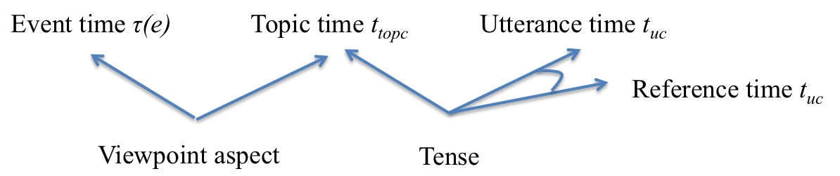
Figure 8. Expanding the tense component of Klein’s (1994) theory
Anaphoric tenses such as the anterior pasts of Japanese and Kituba constrain the topic time variable, not vis-à-vis utterance time, like deictic tenses, but vis-à-vis some reference time given in discourse. However, anaphoric tenses seem to permit exophoric interpretations in reference to the speech situation as well, and this seems in fact to be their default use in matrix clauses in conversation. In hybrid tenses such as those of English and Korean, the deictic tense component does not relate utterance time to topic time, but to reference time. The latter adjustment appears much less radical once reference times are understood as a special kind of topic times. Both the existence of utterances with multiple topic times and that of reference times in addition to topic times are already anticipated in Klein (1994: 218-221) in connection with the phenomenon of tense marking in subordinate clauses. A comparison of the dialogues in (45) and (46) illustrates that discourse reference times are topic times as well:

(45) Q: When you entered Sally’s office, what did she do?
A: She took a notepad from a drawer in her desk, jotted down a phone number, tore off the note, and handed it to me.

(46) Q: When you met with Floyd, what did you find out about his book?
A: He had signed the contract with the publisher, revised the outline, and written a draft of the introductory chapter.

The first dialogue is a standard example of narrative progression. The question sets an initial topic time, which the clauses of the response successively advance. In the second dialogue, the question defines the reference time for the pluperfects in the response. Across the pluperfects, there is again referential shift, suggesting that these forms are interpreted perfectively and therefore as anterior tenses. At the same time, these clauses together provide the requested information concerning the time frame the question asks about – and this time frame is precisely the reference time of the pluperfects. Thus, the pluperfects each have their own topic situation and the topic situations of the pluperfects are all parts of a larger topic situation introduced by the question. In other words, the distinction between reference time and topic time in hybrid tenses introduces a hierarchical structure of times and situations about which the utterance makes an assertion or asks a question, etc. So the finite tense component of hybrid tenses has a single unified meaning that covers both the purely deictic uses of the tense morpheme and its occurrence in the hybrid tense constructions. This unified meaning relates topic time to utterance time. In case the utterance is about multiple topic times, the finite tense component relates the hierarchically highest – the one defined in the surrounding discourse context, i.e., the reference time – to utterance time.

9. Summary
Progress in science is the result of optimizing the trade-off between the parsimony of theories and the range of phenomena, or the set of data, they can account for. A landmark theoretical innovation - the reinterpretation of reference times as topic times – allowed Klein (1992, 1994, 1995, etc.) to revise the traditional theory of tense nowadays associated with Reichenbach 1947, whose roots go back to antiquity. The result is a unified theory of tense and viewpoint aspect, which is able to capture both kinds of phenomena in a highly parsimonious and elegant fashion and which is applicable to tensed and tenseless languages alike and also explains the relation between tense, aspect, and finiteness.
The present article has confronted this simple, elegant theory with additional data from two sources: ambiguity tests suggest that the English pluperfect and future perfect are polysemous rather than vague concerning the distinction between aspectual (perfect-in-the-past/future) and anaphoric tense (past-in-the-past/future) interpretations, and typological evidence from a range of languages suggests that each of these meanings can be expressed in isolation of the other in the languages of the world. The additions to the theory necessary so it can accommodate the new evidence are considerable. They significantly reduce the elegant simplicity of the theory. Such is the nature of scientific progress. However, the theory in its original formulation remains entirely valid for the set of data for which it was originally proposed. One can think of the two versions of the theory as two perspectives on the same idea, a grand vista viewed from on high and the more detailed and fine-grained perspective developed in the present article.

References
Austin, J. L. (1950). Truth. Proceedings of the Aristotelian Society 24(1): 111-129.
Bittner, M. (2005). Future discourse in a tenseless language. Journal of Semantics 22: 339-387.
---- (2008). Aspectual universals of temporal anaphora. In S. Rothstein (Ed.), Theoretical and crosslinguistic approaches to the semantics of aspect. Amsterdam: Benjamins. 349-385.
---- (Ms.). Tense, mood, and centering. Rutgers University manuscript. 2009.
Bohnemeyer, J. (1998). Time relations in discourse: Evidence from Yukatek Maya. PhD thesis, Tilburg University.
---- (2002). The grammar of time reference in Yukatek Maya. Munich: LINCOM.
---- (2009). Linking without grammatical relations in Yucatec: Alignment, extraction, and control. In Y. Nishina, Y. M. Shin, S. Skopeteas, E. Verhoeven, & J. Helmbrecht (Eds.), Issues in functional-typological linguistics and language theory: A Festschrift for Christian Lehmann on the occasion of his 60th birthday. Berlin: Mouton de Gruyter. 185-214.
---- (2012). In the mood for status: Subjunctive and irrealis in Yucatec. Presented at SULA 7: The semantics of under-represented languages in the Americas. Cornell University.
Bohnemeyer, J. & Swift, M. D. (2004). Event realization and default aspect. Linguistics and Philosophy 27(3): 263-296.
Chomsky, N. A. (1971). Deep structure, surface structure, and semantic interpretation. In D. D. Steinberg & L. A. Jakobovits (Eds.), Semantics. Cambridge: Cambridge University Press. 183-216.
Comrie, B. (1976). Aspect. Cambridge: Cambridge University Press.
---- (1981). On Reichenbach’s Approach to Tense. In C. S. Masek & M. F. Miller (Eds.), Papers from the Seventeenth Regional Meeting. Chicago: Chicago Linguistic Society. 24-30.
Cruse, D. A. (1986). Lexical semantics. Cambridge: Cambridge University Press.
Declerck, R. (1991). Tense in English. London: Routledge.
Demirdache , H. & M. Uribe-Etxebarria. (2004). The Syntax of Time Adverbs. In J. Guéron and J. Lecarme (eds.), The Syntax of Time. Cambridge, MA: MIT Press. 217-234.
---- (2007). The Syntax of Time Arguments. Lingua 117: 330-366.
Fortescue, M. (1984). West Greenlandic. London: Croom Helm.
Hinrichs, E. (1986). Temporal Anaphora in Discourses of English. Linguistics and Philosophy 9: 63-82.
Hornstein, N. (1990). As time goes by. Cambridge, MA: MIT Press.
Jespersen, O. (1924). The philosophy of grammar. London: George Allen & Unwin.
Kamp, H. & Reyle, U. (1993). From discourse to logic. Dordrecht: Kluwer.
Klein, W. (1992). The present perfect puzzle. Language 68: 525-552.
---- (1994). Time in language. London: Routledge.
---- (1995). A time-relational analysis of Russian aspect. Language 71: 669-695.
---- (1998). Assertion and finiteness. In N. Dittmar & Z. Penner (Eds.), Issues in the theory of language acquisition: Essays in honor of Jürgen Weissenborn. Bern: Peter Lang. 225-245.
---- (2006). On finiteness. In V. Van Geenhoven (Ed.), Semantics in acquisition. Dordrecht: Springer. 245-272.
---- (2009). Finiteness, universal grammar, and the language faculty. In J. Guo, E. Lieven, N. Budwig, S. Ervin-Tripp, K. Nakamura, & S. Ozcaliskan (Eds.), Crosslinguistic approaches to the psychology of language: Research in the tradition of Dan Isaac Slobin. New York: Psychology Press. 333-344.
Klein, W., Li, P., & Hendriks, H. (2000). Aspect and assertion in Mandarin Chinese. Natural Language & Linguistic Theory 18: 723-770.
Kratzer, A. (2011). Situations in Natural Language Semantics. In E. N. Zalta (Ed.), The Stanford Encyclopedia of Philosophy. <http://plato.stanford.edu/archives/fall2011/entries/situations-semantics/>.
Krifka, M. (1992). Thematic relations as links between nominal reference and temporal constitution. In I. A. Sag & A. Szabolcsi (Eds.), Lexical matters. Menlo Park, CA: CSLI/SRI International. 29-54.
---- (1998). The origins of telicity. In S. Rothstein (Ed.), Events and grammar. Dordrecht: Kluwer. 197-235.
Lee, E. H. (2010). Pluperfects in Korean and English discourse. Journal of Pragmatics 42: 766-780.
McCawley, J. D. (1971). Tense and time reference in English. In C. J. Fillmore & D. T. Langendoen (Eds.), Studies in linguistic semantics. New York, NY: Holt, Rinehart, & Winston. 96-113.
Moens, M. (1987). Tense, Aspect, and Temporal Reference. Ph.D. thesis, University of Edinburgh.
Mufwene, S. S. (1990). Time reference in Kikongo-Kituba. In J. V. Singler (Ed.), Pidgin and creole tense-mood-aspect systems. Amsterdam: Benjamins. 97-118.
Nishiyama, A. & Koenig, J.-P. (2010). What is a perfect state? Language 86: 611-546.
Ogihara, T. (1996). Tense, attitudes and scope. Dordrecht: Kluwer.
---- (1999). Tense and aspect. In N. Tsujimura (Ed.), The handbook of Japanese linguistics. Oxford: Blackwell. 326-348.
Parsons, T. (1990). Events in the semantics of English. Cambridge, MA: MIT Press.
Partee, B. (1984). Nominal and Temporal Anaphora. Linguistics and Philosophy 7: 243-86.
Reichenbach, H. (1947). Elements of Symbolic Logic. London: Macmillan.
Smith, C. S. (1991). The Parameter of Aspect. Dordrecht: Kluwer.
Smith, C. S., E. Perkins, & T. Fernald. (2007). Time in Navajo: Direct and indirect interpretation. International Journal of American Linguistics 73(1): 40-71.
Stowell, T. (2007). The Syntactic Expression of Tense. Lingua 117: 437-463.

* A version of this paper was presented at SULA 2 – The Semantics of Under-represented Languages of the Americas at the University of British Columbia in 2003. I would like to thank the audience and the members of the former Event Representation project at the Max Planck Institute for Psycholinguistics for comments and suggestions. I am particularly grateful to Sotaro Kita, Wolfgang Klein, Eunhee Lee, Mary Swift, Randi Tucker, and the Yucatec consultants who contributed to the paper. I am indebted to the editor of the special issue, María Arché, for extensive comments and for her initiative and leadership in putting the issue together. As a matter of course, the views presented here are my own and any mistakes are my responsibility alone. The research on Yucatec reported on in section 5 was partly supported by the Max Planck Society.
Demirdache & Uribe-Etxebarria (2004, 2007) propose that topic time and event time adverbials occupy distinct functional head positions in the syntax. Klein’s analysis translates into this theory in terms of syntactic ambiguity of the time adverbial.
I collected the Yucatec data in fieldwork with five adult native speakers. For the other languages, I relied on published sources and in some cases in addition expert advise.
See also Arche, this issue, on polysemy of the English simple past marker.
See Bittner (2005, 2008); Bohnemeyer 1998, 2009; Bohnemeyer & Swift 2004; and Smith, Perkins, & Fernald 2007 for some proposals of how temporal interpretation in the absence of tense/aspect marking works.
There are other elements, which I ignore here since they do not directly bear on the subject matter of this article – above all, Klein’s treatment of aktionsart/lexical aspect.
Most of these are adapted from (Cruse 1986: 59-61). A different type of ambiguity test capitalizes on anomaly resulting from coordination of different senses when ellipsis or VP anaphora is involved. Arche (this issue) applies a test of this kind in support of the analysis that stative clauses in the simple past are ambiguous between perfective and imperfective interpretations in English.
Strictly speaking, function words and inflections are of course a part of the mental lexicon anyway, in that the triplets of phonological, morphosyntactic, and semantic information that represent them have to be learned item by item exactly the same way as with lexical items.
Future time reference is different in this respect, since it allows attaching event times to the anticipated or planned (etc.) realization of events. This explains the event time specifications in examples such as I was finishing/going to finish by Monday, but then my hard disk died on me.
Key to abbreviations in morpheme glosses: 1/2/3 - 1st/2nd/3rd person; A - set-A (ergative/possessor) bound pronominal clitic; ACC - accusative; ANT - anterior tense; APP - applicative derivation; ASP - aspect; B - set-B (absolutive) bound pronominal suffix; CAUS - causative derivation; CAUSE - 'becausative' clause-linkage form; CL - classifier; CMP - completive; CON - connective particle; D2 - anaphoric/distal clause-final particle; D3 = text-deictic clause-final particle; D4 - locative/negative clause-final particle; DEC - declarative; DET - determiner; DUB - dubitative; EMPH - emphatic (negation); ERG - ergative; EXP - expected; GEN - genitive; IN - inanimate; INC - incompletive status; LOC - locative; MOD – ‘modalis’ (case); ND - indicative; NEG - negation; NOM - nominative; PAST - past; PERF - perfect; IPL - plural; PLUPERF - pluperfectPOST - posterior tense; PREP - generic (semantically empty) preposition; PRES - present; PRV - perfective; SG - singular; SUBJ - subjunctive status; TE - converb clause-linkage form; TERM - terminative (perfect) aspect;TOP - topic marker; UP - upper bound.
The status suffixes combine viewpoint aspect and mood meanings (Bohnemeyer 1998, 2002, 2009, 2012). The incompletive expresses unmarked mood and, when governed by lexical matrix predicates, imperfective aspect. When selected by a preverbal aspect marker such as ts’o’k, however, -ik does not compositionally contribute to the truth conditions of the utterance. The occurrence of –ik with ts’o’k is presumably a reflex of the diachronic relation between ts’o’k and the homophonous aspectual verb meaning ‘end’.
Thus Chomsky (1971: 212-213) and McCawley (1971: 106-108); Comrie (1976: 59 [fn. 4]) disagrees and rejects (29b) as well (in my view, correctly).
This assumes that event descriptions are necessarily interpreted for viewpoint aspect, but that this interpretation may not be a part of the semantic meaning of the utterance, but merely pragmatically generated and thus defeasible. See Bohnemeyer & Swift 2004 on implicature-based aspectual interpretation.
The motion verb ‘go’ is treated in Figure 5 as introducing an existentially bound path variable h and a function goal that assigns it an endpoint location. I refrain from amending the model theory to reflect these additions since they are not relevant to the topic at hand.
Of course, different formats are needed for different types of calendric time specifications, e.g., time of day (‘morning’, ‘evening’, etc.). And the interpretation of calendric adverbials is obviously subject to considerable vagueness.
A common alternative is to left-dislocate topic time adverbials.

