Path of Travel:

UFAS | Item | Dimension | Yes | No | N/A
Is there an accessible path of travel from the entrance to the site to the entrance of the building in which the dwelling unit is located?

Use other survey forms to determine whether or not these spaces have the necessary features. Cross reference to the applicable forms here:

_______________________________________

 | Is there a reserved accessible parking place assigned to the unit?
If yes, is there an accessible path of travel from the reserved parking place to the entry of the building?

Use other survey forms to determine whether or not these spaces have the necessary features. Cross reference to the applicable forms here:

_______________________________________

Is there an accessible path of travel from the entry of the building to the dwelling unit?

Use other survey forms to determine whether or not these spaces have the necessary features. Cross reference to the applicable forms here:

_______________________________________

Common Spaces:

UFAS | Item | Dimension | Yes | No | N/A
Are common spaces serving the dwelling accessible?

Use other survey forms to check each common space below that is not accessible and identify by cross reference all those that are not:

□ Mailbox:_________
□ Management office:___________
□ One common laundry room: ___________
□ Trash disposal____________
□ Corridors
□ Other (identify)_____________________
□ Other (identify)_____________________
□ Other (identify)_____________________

The five rooms above are the typical concerns in NYCHA housing. NYCHA provides reasonable accommodtions through services if it is technically infeasible to make these spaces and facilities accessible.

Dwelling unit path of travel:

UFAS | Item | Dimension | Yes | No | N/A
4.34.2(15)  4.34.5  4.34.2(13); 4.34.6 | Are the following spaces on an accessible route?  □ living and  □ dining area(s)  □ at least one bathroom  □ kitchen  □ sleeping area (at least 2 in an apartment with 2 or more bedrooms)

Controls in accessible spaces (including thermostats, light switches, etc.):

UFAS | Item | Dimension | Yes | No | N/A
4.34.2(9) (4.27) | Is there a 30 by 48 inch clear floor space in front of the controls which allows either a forward or parallel approach?
4.34.2(9) (4.27) | If the clear ground space allows only a forward approach, then is the highest operable part of the controls no more than 48 inches from the ground?
4.34.2(9) (4.27) | If the clear ground space allows a side approach to the controls, is the highest operable part of the controls no more than 54 inches from the ground?
4.34.2(9) (4.27) | Are the controls operable with one hand?
4.34.2(9) (4.27) | Do they not require any tight grasping, pinching, or twisting of the wrist?

Bathroom:

UFAS | Item | Dimension | Yes | No | N/A
4.34.2(12) | Is at least one full bathroom accessible or adaptable, including a water closet, a lavatory and a bathtub or shower?
4.34.2(12) | Does that unit comply with any of the following diagrams?  If no, skip to 4.34.5.2(1).  Note: According to the Voluntary Compliance Agreement, the design may comply with any of the three designs or the UFAS.

UFAS | Item | Dimension | Yes | No | N/A
Is the bathroom: ( ) Type Ia ( ) Type Ib ( ) Type II ?
Check off the appropriate layout.

Note: If any dimension does not comply with the dimensions in the layouts above, circle the non-compying dimension on the appropriate sketch and write in the actual dimension.
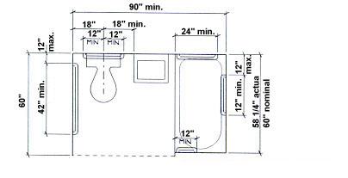
Type Ia

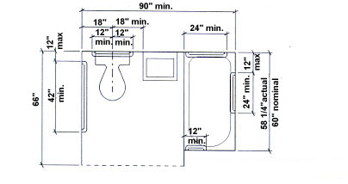
Type Ib

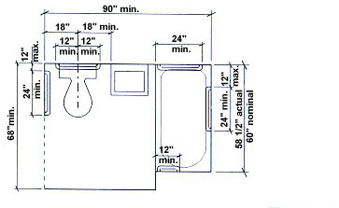

Type II

If the bathroom substantially complies with Type Ia, Type Ib or Type II, skip to 4.34.5.2 (2) Water Closet Height, Page 8.

Item 4.34.5.2(1) on pages 6 and 7 are from the original UFAS Checklist and are provided to use only for bathroom layouts that are not similar to Types Ia, Ib and II.

Water Closets:

UFAS | Item | Dimension | Yes | No | N/A
4.34.5.2(1) | Is the clear space at the toilet provided as shown in Figure 47(a)?  Note: It can be on either side of the toilet.  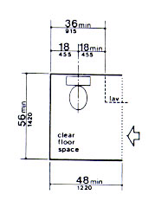  Figure 47a
 | 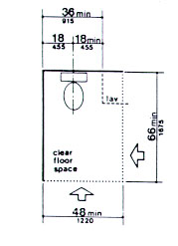

UFAS | Item | Dimension | Yes | No | N/A
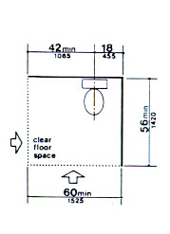

Figure 47a

Note: Clear floor space at fixtures may overlap..

UFAS | Item | Dimension | Yes | No | N/A
4.34.5.2(2) | Is the water closet between 15 and 19 inches high measured from the top of the toilet seat to the finished floor?  Is there structural reinforcement as shown in Figure 47(b)?  Note: NYCHA provides grab bars in all accessible units. Structural reinforcement alone will never be an option.  OR  If provided, are grab bars installed as shown in Figure 29?  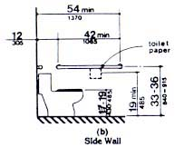  Figure 29
4.34.5.2(4) | Is the toilet paper installed within reach as shown in Figure 29?

Lavatory and Mirror:

UFAS | Item | Dimension | Yes | No | N/A
4.34.5.3(1); 4.22.6; 4.19 | Is the sink 34 inches or less above the floor?  Measure from the floor to the top of the counter.  Do knee and toe clearances comply with Figure 31?  OR  If a cabinet is provided under the lavatory in an adaptable bathroom, is it removable to provide this clearance?  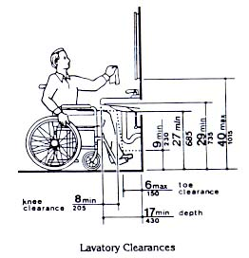  Figure 31
4.34.5.3(1); 4.22.6; 4.19 | Is there at least 29 inches clearance from the floor to the bottom of the apron?  OR  If a cabinet is provided under the lavatory in an adaptable bathroom, is it removable to provide this clearance?
4.34.5.3(1); 4.22.6; 4.19 | Is a clear space 30 x 48 inches provided in front of the lavatory to allow a forward approach? (Also refer to the checklist supplement for bathroom details.)  Note: Clear floor space at fixtures may overlap. Refer to the checklist supplement for bathroom details.

UFAS | Item | Dimension | Yes | No | N/A
 | Does the clear floor space overlap an accessible route?
 | Is no more than 19 inches of the required clear space measured underneath the lavatory?
 | Are hot water and drain pipes under the lavatory insulated or otherwise covered?
 | Are there no sharp or abrasive surfaces under the lavatory?
4.34.5.3(1); 4.22.6; 4.19; 4.27 | Are the faucets operable with one hand and do they not require tight grasping, pinching, or twisting of the wrist?
4.34.5.3(1); 4.22.6; 4.19.6 | Are the mirrors mounted with the bottom edge of the reflecting surface no higher than 40 inches from the floor?
4.34.5.3(3) | If a medicine cabinet is provided, is there a usable shelf inside no higher than 44 inches above the floor?
4.34.5.1 | Are clear spaces required for fixtures free of door swings?

Bathtub:

UFAS | Item | Dimension | Yes | No | N/A
4.34.5.4 | If a bathtub is provided, does it have the following features?
4.34.5.4(1) | Is a clear floor space provided as shown in Figure 33 a?  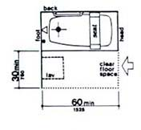 Figure 33a.

UFAS | Item | Dimension | Yes | No | N/A
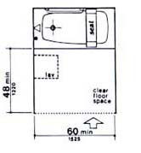 Figure 33b
Note: Clear floor space at fixtures may overlap.
4.34.5.4(2) | Is a seat provided as shown in Figures 33 and 34  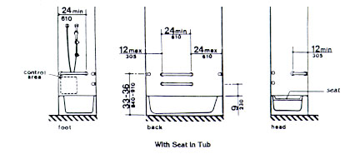  Figure 34  Is the seat mounted securely and does it not slip during use?  Note: The tub seats might not be present at time of inspection. NYCHA furnishes tub seats when resident occupies an apartment.
4.34.5.4(3) | Are structural reinforcements or other provisions that will allow installation of grab bars provided in the locations shown in Figure 48?  Note: NYCHA provides grab bars in all accessible units. Structural reinforcement alone will never be an option.  OR  If grab bars are installed, are they as shown in Figure 34?

UFAS | Item | Dimension | Yes | No | N/A
4.16.4; 4.26 | Is the diameter of the grab bar between 1¼ inch and 1½ inch?  OR  Does the shape provide an equivalent gripping surface?
4.16.4; 4.26 | Are the grab bars 1½ inch away from the wall?
4.16.4; 4.26 | Are the grab bars secured so that they do not rotate within their fittings?
4.16.4; 4.26 | Is the grab bar and the wall adjacent to it free of any sharp or abrasive elements?
4.34.5.4(4) | Are the controls located as shown in Figure 34?
4.34.5.4(4); 4.27.4 | Are the control operable with one hand, and do they not require any tight grasping, pinching, or twisting of the wrist?
4.34.5.4(5) | Is a shower unit provided which can be used as fixed unit at various heights or as a hand held shower with a hose at least 60 inches long?

Kitchen:

UFAS | Item | Dimension | Yes | No | N/A
4.34.6.1 | Is the clearance between all opposing cabinet, counter, appliances or walls at least 40 inches except in U-shaped kitchens where the clearance must be 60 inches?
4.34.6.2; 4.2.4 | Is there 30 x 48 inches clear space at appliances?

Counters:

UFAS | Item | Dimension | Yes | No | N/A
4.34.6.4 | Is there at least one 30 inch section of counter which is no more than 34 inches above the floor measured from the floor to the top of the counter?
4.34.6.4 | Does this section have a 30 inch wide and 19 inch deep clear knee space?  OR  If this section of counter has base cabinets, are they removable to provide the minimum clearance?
4.34.6.4 | Does the floor finish extend underneath the counter to the wall?
4.34.6.4 | Is the counter and its supporting structure 2 inches thick or less?
4.34.6.4 | Is there a 30 x 48 inch clear floor space at this counter? (19 of the 48 inches can extend under the counter.)
4.34.6.4 | Are there no sharp or abrasive surfaces under the counter?

Sink:

UFAS | Item | Dimension | Yes | No | N/A
4.34.6.5(1) | Is the sink and surrounding counter mounted no more than 34 inches above the floor measured from the floor to the top of the counter?
4.34.6.5(1) | Is the sink and counter area at least 30 inches wide?
4.34.6.5(3) | Is the sink depth a maximum of 6.5 inches? (Only one bowl of a double or triple bowl sink needs to meet this requirement.)
4.34.6.5(4); 4.27.4 | Are the faucets operable with one hand and do they not require any tight grasping, pinching or twisting of the wrist?
4.34.6.5(6) | Is the counter and supporting structure 2 inches thick or less?
4.34.6.5(7) | Is there 30 x 48 inches clear floor space allowing a forward approach to the sink?
4.34.6.5(7) | Is there a clear knee space 30 inches wide and 19 inches deep under the counter?  OR
4.34.6.5(5) | If provided, are base cabinets at the sink removable to provide at least a 30 inch wide knee space under the sink and surrounding counter?
4.34.6.5(5) | Does the finished floor extend under the counter to the wall?
4.34.6.5(8) | Are there no sharp or abrasive surface under the sink?
4.34.6.5(8) | Are the hot water and drain pipes insulated or otherwise covered?

Range/Cooktop/Oven:

UFAS | Item | Dimension | Yes | No | N/A
4.34.6.6; 4.34.6.2 | Is a clear floor space at least 30 x 48 inches which allow either a forward or parallel approach provided at the range or cooktop?
4.34.6.6; 4.34.6.3; 4.27 | Can the controls be operated with one hand, and do they not require any tight grasping, pinching, or twisting of the wrist?  Note: Appliances that are in compliance might not be present at time of inspection. NYCHA generally installs appliances just prior to tenant moving in.
4.34.6.6; 4.34.6.3; 4.27 | Does the location of the controls allow them to be used without reaching across burners?  Note: Appliances that are in compliance might not be present at time of inspection. NYCHA generally installs appliances just prior to tenant moving in
4.34.6.6 | If there is knee space underneath the cooktop, is there insulation or other protection against burns, abrasions, or electrical shock?
4.34.6.7; 4.34.6.2 | Is there a clear floor space at least 30 x 48 inches which allows either a forward or a parallel approach to the oven?
4.34.6.7; 4.34.6.3; 4.27 | Can the oven controls be operated with one hand, and do they not require any tight grasping, pinching, or twisting of the wrist?
4.34.6.7; 4.34.6.3; 4.27 | Does the location of the controls allow them to be used without reaching across burners?
4.34.6.7 | Is the oven self-cleaning?  OR  Is it located next to an adjustable height counter with knee space below?

Refrigerator/Freezer:

UFAS | Item | Dimension | Yes | No | N/A
4.34.6.8; 4.34.6.3; 4.27 | Can the refrigerator controls be operated with one hand, and do they not require any tight grasping, pinching, or twisting of the wrist?
4.34.6.8; 4.34.6.3; 4.27 | Does a clear floor space of 30 x 48 inches provide either a front or a parallel approach to the refrigerator/freezer?
4.34.6.8; 4.34.6.3; 4.27 | If only a front approach is provided, are the controls no higher than 48 inches?
4.34.6.8; 4.34.6.3; 4.27 | If a parallel approach is provided, are the controls no higher than 54 inches?

Kitchen Storage:

UFAS | Item | Dimension | Yes | No | N/A
4.34.6.9; 4.34.6.3; 4.27 | Are the controls operable with one hand?
4.34.6.9; 4.34.6.3; 4.27 | Do they not require any tight grasping, pinching, or twisting of the wrist?
4.34.6.10; 4.25.2 | Is there a clear floor space 30 x 48 inches at storage facilities which allows for either a forward or side approach in a wheelchair?
4.34.6.10; 4.25.3 | If a side approach is provided, is the storage space between 9 and 54 inches from the floor?
4.34.6.10; 4.25.3 | If a front approach is provided, is the storage space between 15 and 48 inches from the floor?
4.34.6.10; 4.25.4; 4.27.4 | Is the hardware operable with one hand and does it not require any tight grasping, pinching, or twisting of the wrist?
4.34.6.10(2) | Are the door pulls for wall cabinets as close to the bottom of the cabinet doors as possible?
4.34.6.10(2) | Are base cabinet handles as close to the top of the cabinet doors as possible?

UFAS | Item | Dimension | Yes | No | N/A
4.34.6.10(1) | Is at least one usable shelf of all cabinets and storage shelves 48 inches or less above the floor?

Controls:

UFAS | Item | Dimension | Yes | No | N/A
4.34.6.3; 4.27 | Do all of the controls in the kitchen (including light switches, garbage disposal switches, fan switches, etc.) meeting the following criteria:
4.34.6.3; 4.27 | Is there a clear floor space which allows either a forward or a parallel approach to the controls?
4.34.6.3; 4.27 | If only a forward approach is provided, are the controls no more than 48 inches from the ground?
4.34.6.3; 4.27 | If a parallel approach is provided, are the controls no more than 54 inches from the ground?
4.34.6.3; 4.27 | Are the controls operable with one hand and do they not require any tight grasping, pinching or twisting of the wrist?

